0

# Lab #4

# Proxmox Server

# Week #06/07/08

# NACT-262 Fundamentals of System Administration

# 2025-2026 Fall Semester

# Submitted by Jibreal Id-deen

# Due by October 19

# Professor Mark Jeremy

Table Of Contents

Objective 10

Network DIAGRAM 11

Procedure 14

Questions and Answers 168

Observations 169

Table of Figures

Figure 1 - Create an administrator password on TP-Link Wi-Fi Router 15

Figure 2 - Click "Exit Setup" in the wizard process 16

Figure 3 - Click "advanced" 16

Figure 4 - Click "LAN" 17

Figure 5 - Change the LAN IP Address 18

Figure 6 - Save it 18

Figure 7 - Click "DHCP Server" 19

Figure 8 - Disable the DHCP Server 20

Figure 9 - Click "Internet" 20

Figure 10 - Disable 2.4GHz and 5Ghz 21

Figure 11 - Save it 22

Figure 12 - Click "disable anyway" 22

Figure 13 - Type the required text and click "Network Connections" 23

Figure 14 - Click Ethernet 23

Figure 15 - Click IPv4 24

Figure 16 - Type the required manually IPv4 Properties and click "OK" 25

Figure 17 - In Dell Server, wait for the Window Server 2019 to boot up 26

Figure 18 - Click "Computer name" 27

Figure 19 - Type the required text and click "OK" 27

Figure 20 - Restart the computer to apply these changes 28

Figure 21 - Go to Microsoft Azure, then click "Education" 28

Figure 22 - Click "Software" 29

Figure 23 - Click "Window Server 2019 Standard" to download 30

Figure 24 - Download it 31

Figure 25 - Type the required text to open the VMware Workstation Pro 32

Figure 26 - Create a New Virtual Machine 33

Figure 27 - Procced the VM Wizard 34

Figure 28 - Make sure to select the WS Server 2019 as ISO 35

Figure 29 - Use the version of WS as Standard (GUI) 36

Figure 30 - Use the bridged mode and replicate 37

Figure 31 - Use Edit then click VME 38

Figure 32 - Change the Settings 39

Figure 33 - Use the required network type to apply and click "OK" 40

Figure 34 - Use the version of WS as Core 41

Figure 35 - Use the required type of network to apply and click "Ok" 42

Figure 36 - Type the required text to click "RUN" 43

Figure 37 - Type the required text to open the ntid files for OS 44

Figure 38 - Click OS 44

Figure 39 - Click WS 10 45

Figure 40 - Drag it to the desktop 45

Figure 41 - Create a New VM 45

Figure 42 - Make sure to select the WS 10 as ISO 46

Figure 43 - Select the WS 10 pro as the version of Windows 47

Figure 44 - In the VM WS 2019 GUI, change the computer name 48

Figure 45 - Type the required text to change the computer name 49

Figure 46 - Go to the Control Panel 50

Figure 47 - Click Network and Internet 50

Figure 48 - Click Network and Sharing Center 50

Figure 49 - Click "Change adapter settings" 51

Figure 50 - Click Ethernet0 51

Figure 51 - Type the required manually IPv4 properties and click "OK” 52

Figure 52 - In VM WS 2019 Core, type "sconfig" to see the internet information 53

Figure 53 - Change the computer name 53

Figure 54 - Type the required text to change the computer name 53

Figure 55 - Restart the computer to apply these changes 54

Figure 56 - The showcase of the computer name 54

Figure 57 - Go to Network Settings 54

Figure 58 - Use the number one to change the network IP Address 55

Figure 59 - Set the network Adapter Address 55

Figure 60 - Set the required manually IP Address 55

Figure 61 - Set DNS Servers 56

Figure 62 - Set the required manually DNS text on it 56

Figure 63 - Done successfully set it 57

Figure 64 - The showcase of the network setting 57

Figure 65 - In VM Window 10, installing 58

Figure 66 - Boot the window 10 up 59

Figure 67 - On WS 10 search, type the required text to check on the network lists 59

Figure 68 - Click Ethernet0 60

Figure 69 - Put the required manually IPv4 on it and click "OK" 61

Figure 70 - In Search, type "About your PC" to click 62

Figure 71 - Click "Rename this PC" 63

Figure 72 - Click "Change" 64

Figure 73 - Change the computer name 65

Figure 74 - Add roles and Features 66

Figure 75 - Select DHCP and DNS Server 67

Figure 76 - Starting Installation 68

Figure 77 - Click "DNS" 68

Figure 78 - Click "New zone" 69

Figure 79 - Proceed to the New Zone 70

Figure 80 - Successfully completed the new zone Wizard 74

Figure 81 - Proceed to the New Zone for Reverse 75

Figure 82 - Make sure to select IPv4 Reverse Lookup Zone 77

Figure 83 - Put the required IPv4 manually on the Network ID 77

Figure 84 - Completed the New Zone Wizard 78

Figure 85 - Click New Host for A to assign the devices 79

Figure 86 - Assign the devices by using their static IPv4 address 80

Figure 87 - Done assigning all of the devices 85

Figure 88 - Use the nslookup command on the DNS Server 86

Figure 89 - On the Dell Server, select DHCP and AD Server 87

Figure 90 - Starting Installation 88

Figure 91 - Promote the server to a domain controller 88

Figure 92 - Add a new forest and type the root domain name 88

Figure 93 - Type the DSRM Password 89

Figure 94 - Create DNS Delegation 89

Figure 95 - Make sure to check the prerequisites passed 89

Figure 96 – Install 90

Figure 97 - The AD Service is starting in effect 90

Figure 98 - Make sure to check if you are in the right domain group 91

Figure 99 - On VM one, click "About your PC" 91

Figure 100 - Click "SYSTEM INFO" 92

Figure 101 – Click Change settings on that 92

Figure 102 - Type the required text with .com on the member of the Domain 93

Figure 103 - Log in to the domain account with Administrator 93

Figure 104 - Successfully joined the domain 94

Figure 105 - Restart the computer to apply these changes 94

Figure 106 - Type the one number to press the domain/workgroup 95

Figure 107 - Press "D" to join the domain and type the required text 95

Figure 108 - Log in to the domain group with administrator status 95

Figure 109 - Restart the computer 96

Figure 110 - The showcase of the domain group 96

Figure 111 - On VM Windows 10, click Advanced System Settings 96

Figure 112 - Do the same thing as what I did on VM 1 97

Figure 113 - Successfully joined the domain 97

Figure 114 - Log out from the WS 10 account 98

Figure 115 - Log in with Administrator status 99

Figure 116 - On WS 10 search, click "Add an optional feature" 100

Figure 117 - Add a feature 100

Figure 118 - Type "RSAT" to add an optional feature 101

Figure 119 - Select all of the required RSAT services 101

Figure 120 – Installing 102

Figure 121 - Select another RSAT service 102

Figure 122 - Installation successfully 103

Figure 123 - Click "Add other servers to manage" 104

Figure 124 - Click "Find now" 105

Figure 125 - Invite those OS to join the server 105

Figure 126 - Invite successfully 106

Figure 127 - All of the servers are online successfully 106

Figure 128 - Type "proxmox" on the google 107

Figure 129 - Download it 107

Figure 130 - Type "Rufus" on the google 108

Figure 131 - Download it 108

Figure 132 - Use USB to boot Proxmox and click "Start" 109

Figure 133 - Ready to boot 110

Figure 134 - Proxmox boot completed! 111

Figure 135 - Set the required IPv4 address and DNS server manually on it 112

Figure 136 - Use this server url to configure 112

Figure 137 - Use this server url to go 113

Figure 138 - Log in the Proxmox VE 113

Figure 139 - Click "PVE" then local pve 114

Figure 140 - Click "ISO Images" 115

Figure 141 - Click "Upload" 116

Figure 142 - Make sure to use WS Server 2019 to upload 116

Figure 143 - Upload another WS 2019 server again 117

Figure 144 - Type "Ubuntu" on Google 118

Figure 145 - download the linux 118

Figure 146 - Upload the Linux ISO file 119

Figure 147 - Create VMS 119

Figure 148 - Create a VM for Windows Server 2019 120

Figure 149 - Create another VM for Windows Server 2019 120

Figure 150 - Create another VM for the Ubuntu client 120

Figure 151 - Click "Console" for the VM WS Server 2019 121

Figure 152 - Start now 122

Figure 153 - Boot the Windows Server 2019 up 123

Figure 154 - Proceed with the WS Server 2019 for VM1 and VM2 124

Figure 155 - Click the version with the GUI 125

Figure 156 - Installing Windows 125

Figure 157 - Create an administrator password 126

Figure 158 - Change the computer name for VM1 126

Figure 159 - Change the computer name to apply these changes 127

Figure 160 - Go to Network Connections and click "Ethernet" 128

Figure 161 - Click "Properties" 129

Figure 162 - Set the required static IPv4 and DNS on it 130

Figure 163 - Select IIS and AD Service to install 131

Figure 164 - Installation completed 132

Figure 165 - Promote the server to a domain controller 132

Figure 166 - Add a domain controller to an existing domain and type the name of domain 132

Figure 167 - Log in to the existing domain with administrator status 133

Figure 168 - Select a domain from the forest 134

Figure 169 - Set the DSRM Password 135

Figure 170 - AD installation in the effect 135

Figure 171 - Click the computer name to change 135

Figure 172 - Change the computer name 136

Figure 173 - Set the required static manually with DNS on it 137

Figure 174 - Click "WORKGROUP" 138

Figure 175 - Click Change 139

Figure 176 - Type the name of the domain to join 140

Figure 177 - Log in to the domain with Administrator status 141

Figure 178 - Successfully joined the domain 141

Figure 179 - On the Dell server, complete the DHCP configuration 142

Figure 180 - Authorizing the DHCP server 142

Figure 181 - From the tools, then click DHCP 143

Figure 182 - Click New Scope 144

Figure 183 - Proceed with the new Scope Wizard for DHCP 145

Figure 184 - DHCP Configuration completed. now activate the scope 150

Figure 185 - Make sure to check that the Scope is active 150

Figure 186 - Boot the Ubuntu 151

Figure 187 - Check that Ubuntu gets a DHCP IP address 152

Figure 188 - On Ptoxmox VM 1 WS server 2019, run PowerShell as Administrator 152

Figure 189 - Use the command to install the Web Server 153

Figure 190 - Use the HTML coding language to create a website 153

Figure 191 - Do the same thing for another VM with WS server 2019 153

Figure 192 - On VM Windows 10, use the Edge website to look 154

Figure 193 - Type the IP Address to look 154

Figure 194 - The showcase of the website created by Proxmox VM 155

Figure 195 - Do the same thing for another VM on Proxmox 155

Figure 196 - The showcase of the website created by second VM on Proxmox 155

Figure 197 - On Ptoxmox VM Linux, go to Firefox to look 156

Figure 198 - Type the IP Address from the VM to look 156

Figure 199 - the showcase of the website created by VM on proxmox 157

Figure 200 - Do the same thing from the earlier with another IP Address from VMS 157

Figure 201 - Use nookup command to look at the IP address and DNS name for PC1 158

Figure 202 - nslookup for Router 158

Figure 203 - nslookup on iDRAC 159

Figure 204 - nslookup on VM 159

Figure 205 - nslookup on Windows 10 160

Figure 206 - nslookup on another VMs 160

Figure 207 - nslookup on Dell Server 161

Figure 208 - nslookup on Windows Server 2019 Core 161

Figure 209 - in ubuntu, use nslookup on PC1 162

Figure 210 - nslookup on router 163

Figure 211 - nslookup on iDRAC 163

Figure 212 - nslookup on VMs 165

Figure 213 - nslookup on Windows 10 166

Figure 214 - nslookup on VM 166

Figure 215 - nslookup on Dell Server 167

Figure 216 - nslookup on Windows Server 2019 Core 167

## Lab #4 – Proxmox Server

### Objective

As an independent working on this, I set up a Proxmox-based lab network and deployed three VMS, joined the Windows VM to iddeenjibreal.com, and verified end-to-end DNS/AD/IIS functionality.

### Network DIAGRAM

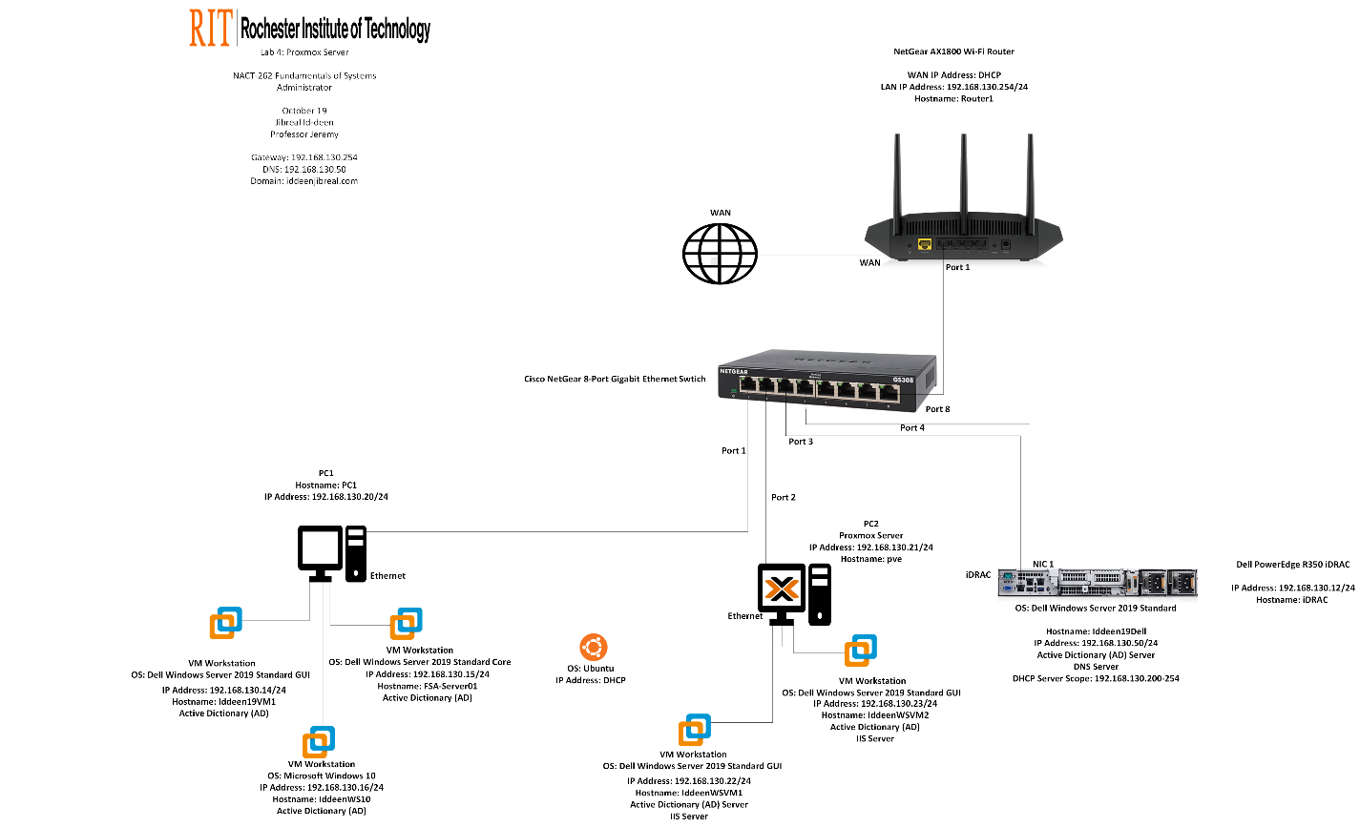

|  |  |
| --- | --- |
| Hostname | iDRAC |
| Virtual Machine or Physical? | Physical |
| Operating System | iDRAC9 firmware |
| RAM size | 128GB |
| HD size | 4TB |
| IPMI IP Address (if none – remove line) | 192.168.130.12 |
| IPMI Gateway IP address (if none – remove line) | 192.168.130.254 |
| Primary DNS IP Address (if none – remove line) | 192.168.130.50 |
| Network Services (if none – remove line) | Remote management |

|  |  |
| --- | --- |
| Hostname | Ideen19Dell |
| Virtual Machine or Physical? | Physical |
| Operating System | Windows Server 2019 Standard (GUI) |
| RAM size | 32GB |
| HD size | 4TB |
| IPMI IP Address (if none – remove line) | 192.168.130.12 |
| IPMI Gateway IP address (if none – remove line) | 192.168.130.254 |
| Ethernet #1 IP Address (if none – remove line) | 192.168.130.50 |
| Ethernet Gateway IP Address (if none – remove line) | 192.168.130.254 |
| Primary DNS IP Address (if none – remove line) | 192.168.130.50 |
| Network Services (if none – remove line) | AD DS, DNS, DHCP (scope 192.168.130.200-249) |

|  |  |
| --- | --- |
| Hostname | Router1 |
| Virtual Machine or Physical? | Physical |
| Operating System | Netgear AX1800 firmware |
| Ethernet #1 IP Address (if none – remove line) | 192.168.130.254 |
| Network Services (if none – remove line) | Gateway/NAT (Wi-Fi disabled) |

|  |  |
| --- | --- |
| Hostname | PC1 |
| Virtual Machine or Physical? | Physical |
| Operating System | Window 11 |
| RAM size | 32GB |
| HD size | 1TB |
| Ethernet #1 IP Address (if none – remove line) | 192.168.130.20 |
| Ethernet Gateway IP Address (if none – remove line) | 192.168.130.254 |
| Primary DNS IP Address (if none – remove line) | 192.168.130.50 |

|  |  |
| --- | --- |
| Hostname | Iddeen19VM1 |
| Virtual Machine or Physical? | VM |
| Operating System | Windows Server 2019 Standard (GUI) |
| RAM size | 8GB |
| Ethernet #1 IP Address (if none – remove line) | 192.168.130.14 |
| Ethernet Gateway IP Address (if none – remove line) | 192.168.130.254 |
| Primary DNS IP Address (if none – remove line) | 192.168.130.50 |
| Network Services (if none – remove line) | Domain member |

|  |  |
| --- | --- |
| Hostname | FSA-Server01 |
| Virtual Machine or Physical? | VM |
| Operating System | Windows Server 2019 Standard Core |
| RAM size | 8GB |
| Ethernet #1 IP Address (if none – remove line) | 192.168.130.15 |
| Ethernet Gateway IP Address (if none – remove line) | 192.168.130.254 |
| Primary DNS IP Address (if none – remove line) | 192.168.130.50 |
| Network Services (if none – remove line) | IIS (custom homepage) |

|  |  |
| --- | --- |
| Hostname | IddeenWS10 |
| Virtual Machine or Physical? | VM |
| Operating System | Windows 10 |
| RAM size | 8 GB |
| Ethernet #1 IP Address (if none – remove line) | 192.168.130.16 |
| Ethernet Gateway IP Address (if none – remove line) | 192.168.130.254 |
| Primary DNS IP Address (if none – remove line) | 192.168.130.50 |
| Network Services (if none – remove line) | RSAT admin workstation |

|  |  |
| --- | --- |
| Hostname | pve |
| Virtual Machine or Physical? | Physical |
| Operating System | Proxmox VE |
| RAM size | 32GB |
| Ethernet #1 IP Address (if none – remove line) | 192.168.130.21 |
| Ethernet Gateway IP Address (if none – remove line) | 192.168.130.254 |
| Primary DNS IP Address (if none – remove line) | 192.168.130.50 |

|  |  |
| --- | --- |
| Hostname | IddeenWSVM1 |
| Virtual Machine or Physical? | VM |
| Operating System | Windows Server 2019 Standard (GUI) |
| RAM size | 8GB |
| Ethernet #1 IP Address (if none – remove line) | 192.168.130.22 |
| Ethernet Gateway IP Address (if none – remove line) | 192.168.130.254 |
| Primary DNS IP Address (if none – remove line) | 192.168.130.50 |
| Network Services (if none – remove line) | AD DS, DNS, IIS |

|  |  |
| --- | --- |
| Hostname | IddeenWSVM2 |
| Virtual Machine or Physical? | VM |
| Operating System | Windows Server 2019 Standard (GUI) |
| RAM size | 8GB |
| Ethernet #1 IP Address (if none – remove line) | 192.168.130.23 |
| Ethernet Gateway IP Address (if none – remove line) | 192.168.130.254 |
| Primary DNS IP Address (if none – remove line) | 192.168.130.50 |
| Network Services (if none – remove line) | IIS |

|  |  |
| --- | --- |
| Hostname | Pve-linux |
| Virtual Machine or Physical? | VM |
| Operating System | Ubuntu Desktop |
| RAM size | 8GB |
| Ethernet #1 IP Address (if none – remove line) | 192.168.130.200 (DHCP) |
| Ethernet Gateway IP Address (if none – remove line) | 192.168.130.254 |
| Primary DNS IP Address (if none – remove line) | 192.168.130.50 |
| Network Services (if none – remove line) | AD DS, DNS, DHCP (scope 192.168.130.200-249) |

### Procedure

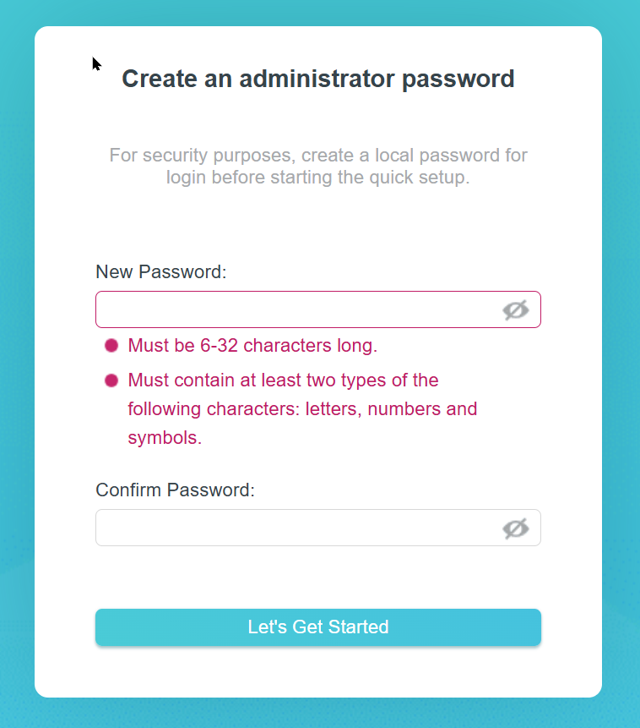

Figure - Create an administrator password on TP-Link Wi-Fi Router

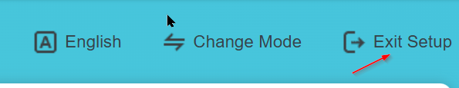

Figure - Click "Exit Setup" in the wizard process

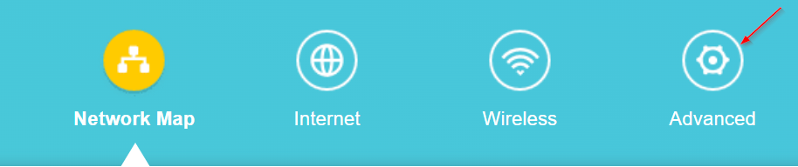

Figure - Click "advanced"

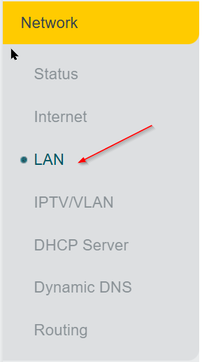

Figure - Click "LAN"

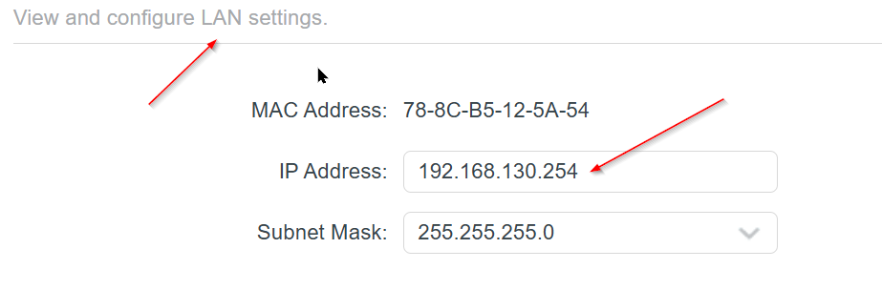

Figure - Change the LAN IP Address



Figure - Save it

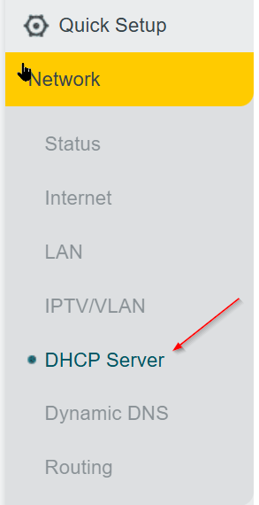

Figure - Click "DHCP Server"

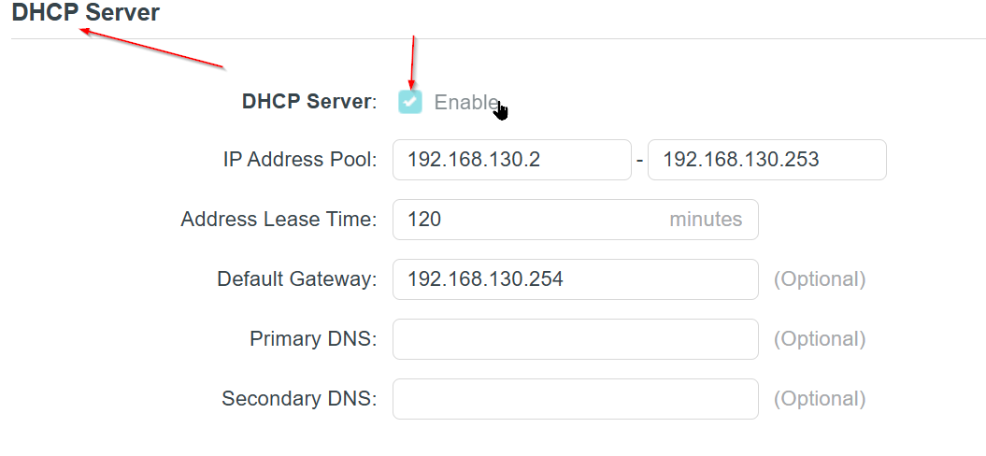

Figure - Disable the DHCP Server

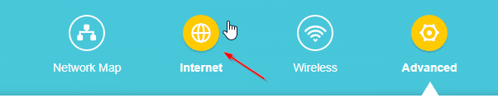

Figure - Click "Internet"

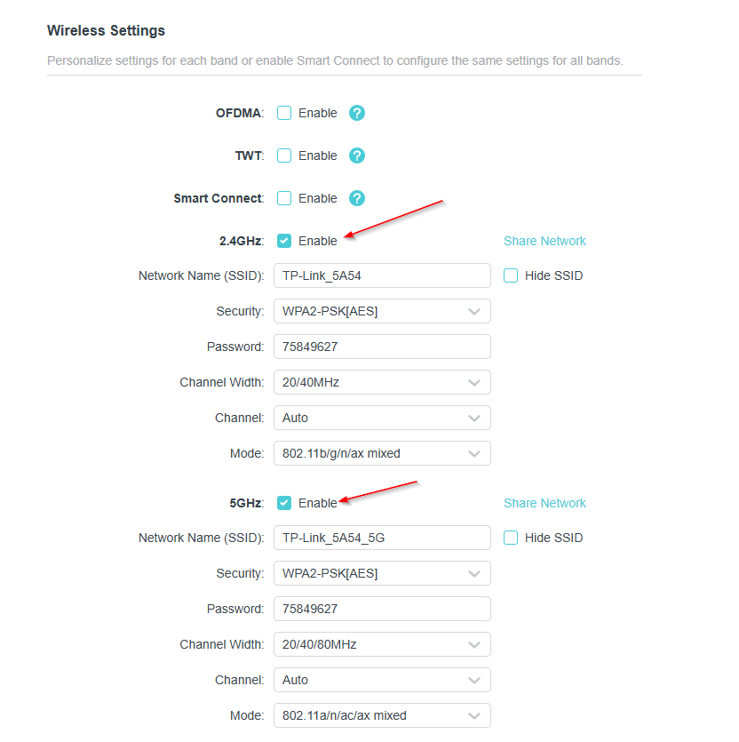

Figure - Disable 2.4GHz and 5Ghz



Figure - Save it

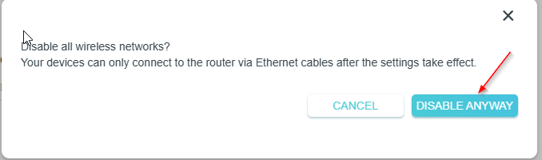

Figure - Click "disable anyway"

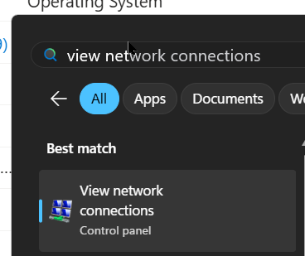

Figure - Type the required text and click "Network Connections"

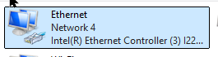

Figure - Click Ethernet

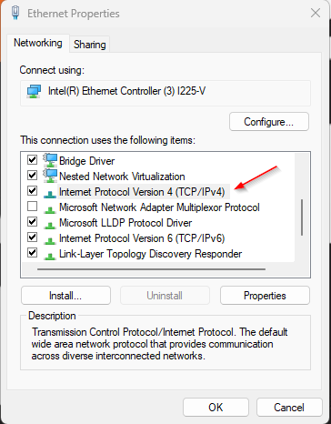

Figure - Click IPv4

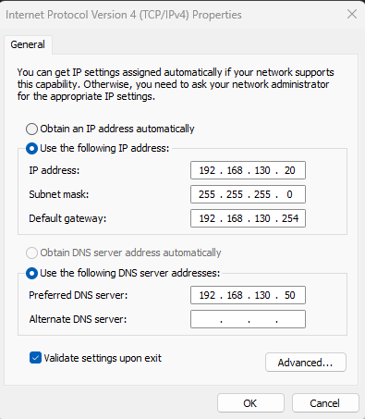

Figure - Type the required manually IPv4 Properties and click "OK"



Figure - In Dell Server, wait for the Window Server 2019 to boot up

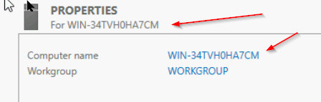

Figure - Click "Computer name"

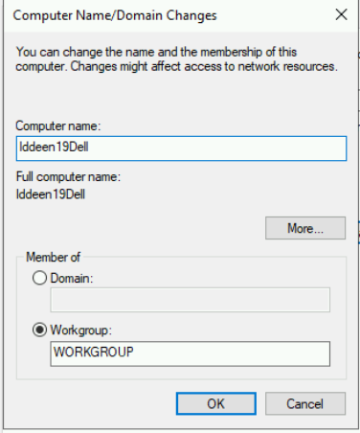

Figure - Type the required text and click "OK"

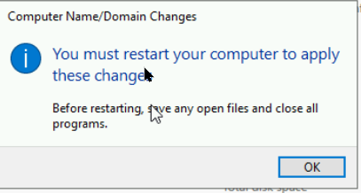

Figure - Restart the computer to apply these changes

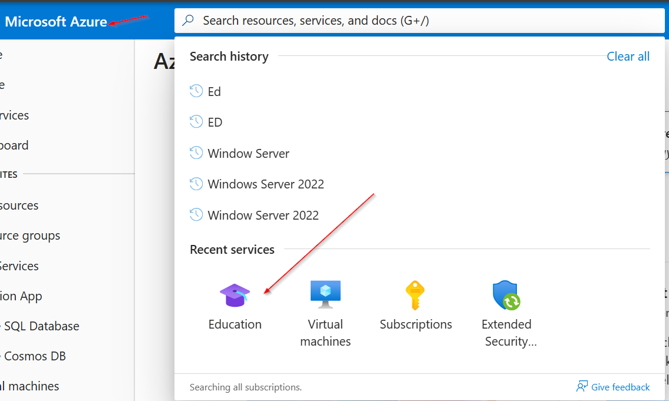

Figure - Go to Microsoft Azure, then click "Education"

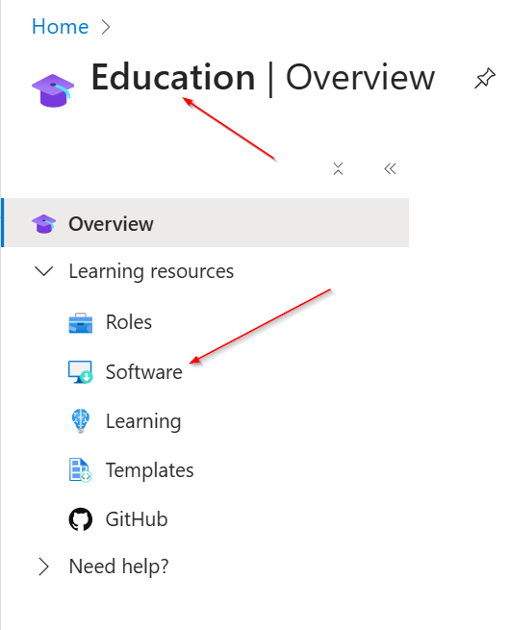

Figure - Click "Software"

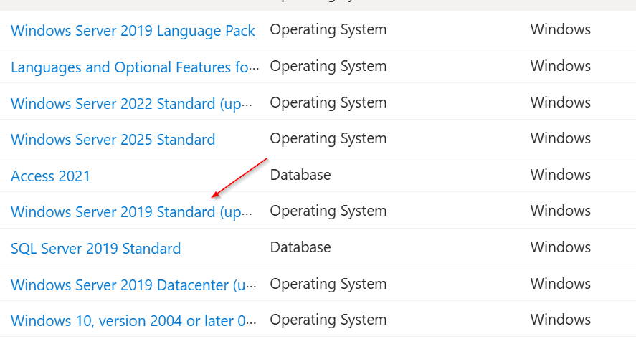

Figure - Click "Window Server 2019 Standard" to download

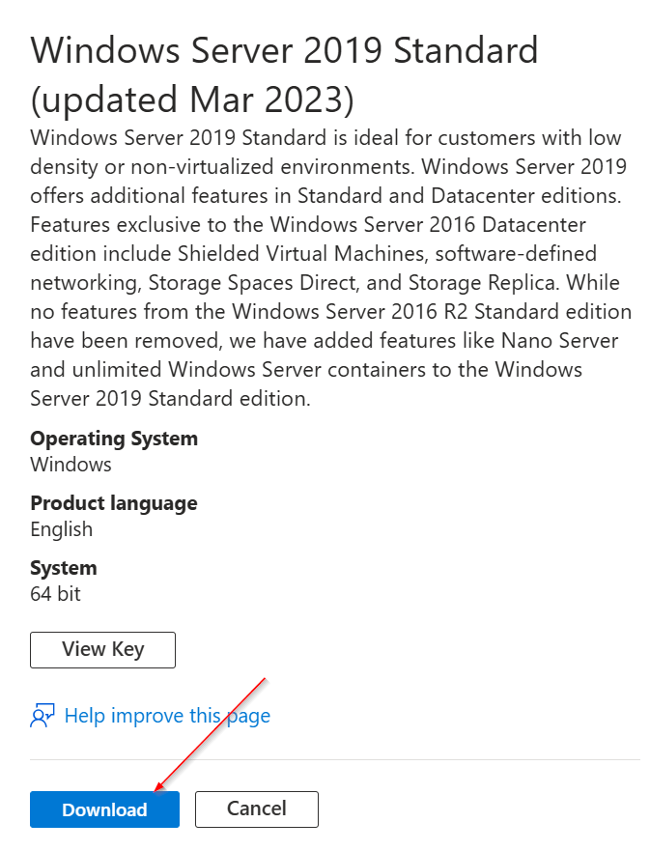

Figure - Download it

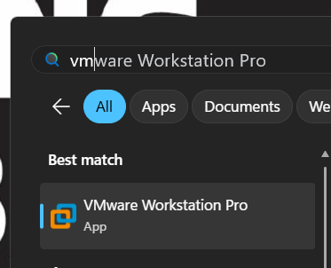

Figure - Type the required text to open the VMware Workstation Pro

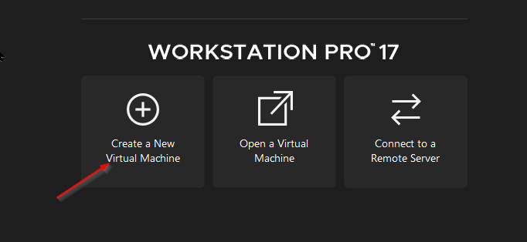

Figure - Create a New Virtual Machine

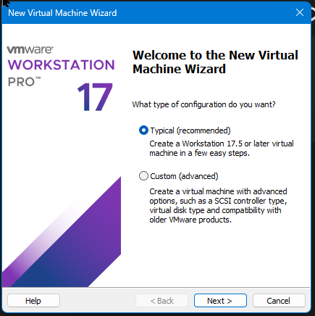

Figure - Procced the VM Wizard

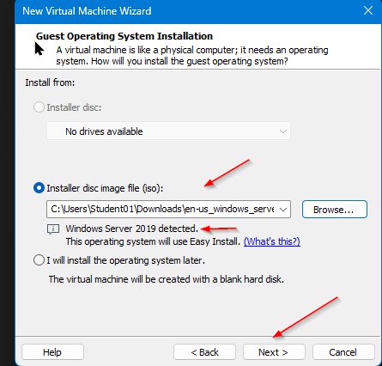

Figure - Make sure to select the WS Server 2019 as ISO

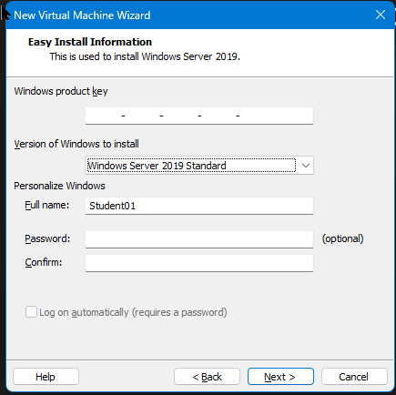

Figure - Use the version of WS as Standard (GUI)

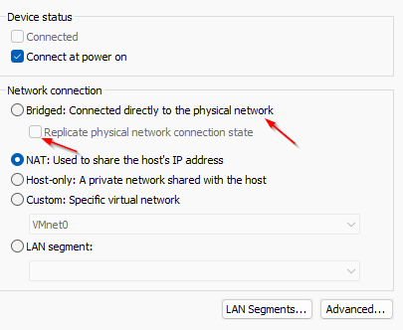

Figure - Use the bridged mode and replicate

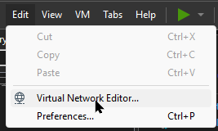

Figure - Use Edit then click VME

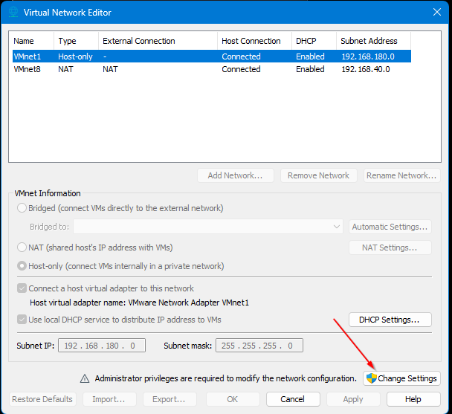

Figure - Change the Settings

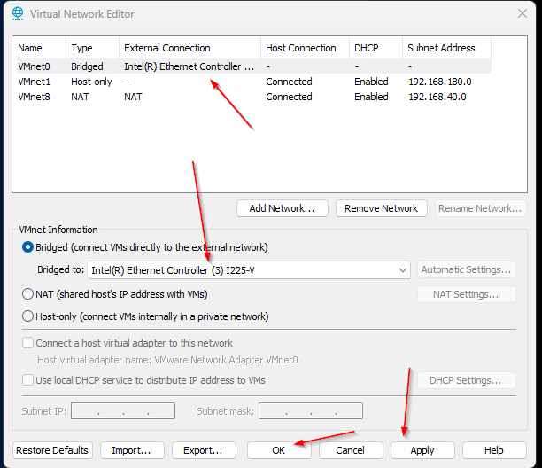

Figure - Use the required network type to apply and click "OK"

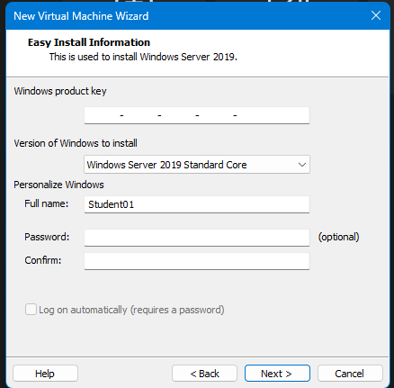

Figure - Use the version of WS as Core



Figure - Use the required type of network to apply and click "Ok"

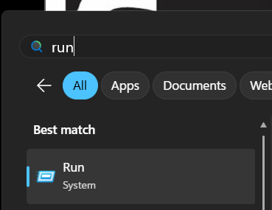

Figure - Type the required text to click "RUN"

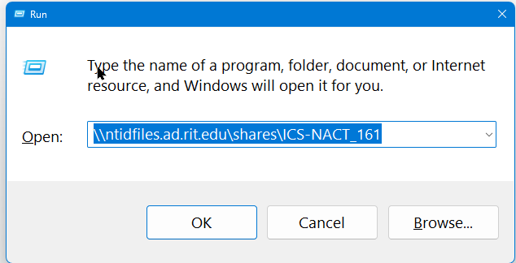

Figure - Type the required text to open the ntid files for OS

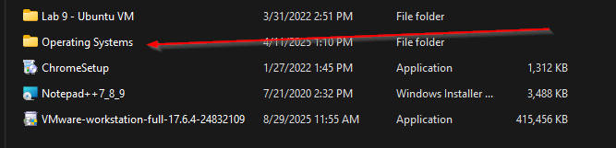

Figure - Click OS

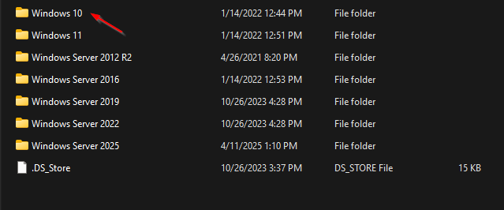

Figure - Click WS 10

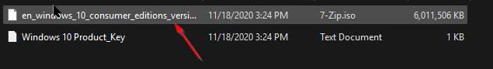

Figure - Drag it to the desktop



Figure - Create a New VM

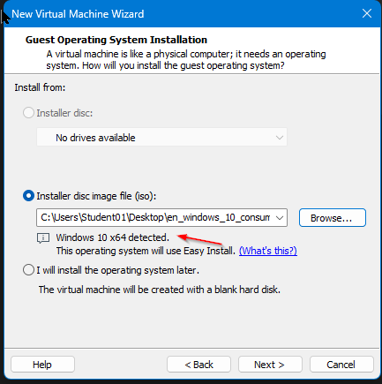

Figure - Make sure to select the WS 10 as ISO

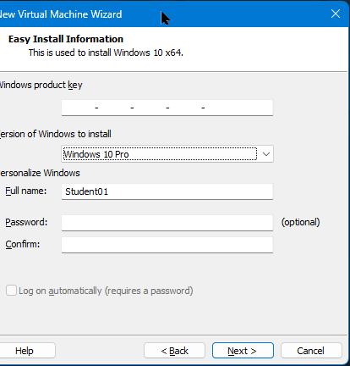

Figure - Select the WS 10 pro as the version of Windows

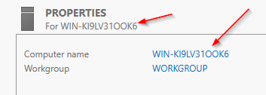

Figure - In the VM WS 2019 GUI, change the computer name

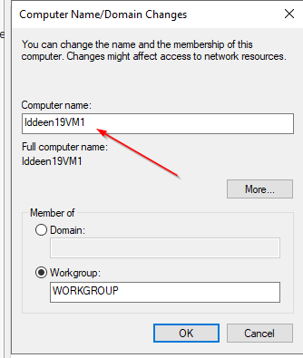

Figure - Type the required text to change the computer name

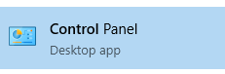

Figure - Go to the Control Panel

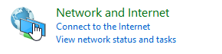

Figure - Click Network and Internet

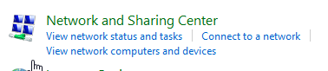

Figure - Click Network and Sharing Center

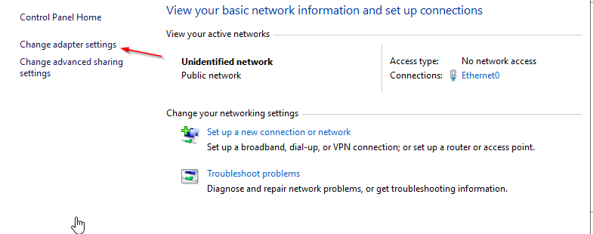

Figure - Click "Change adapter settings"

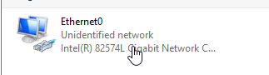

Figure - Click Ethernet0

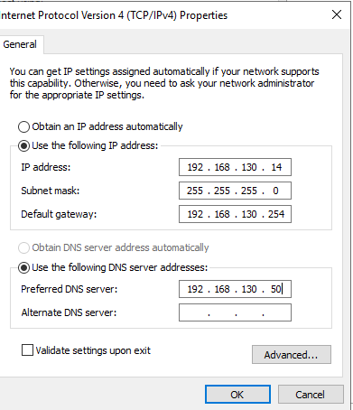

Figure - Type the required manually IPv4 properties and click "OK”

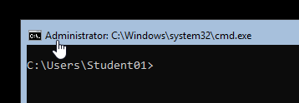

Figure - In VM WS 2019 Core, type "sconfig" to see the internet information

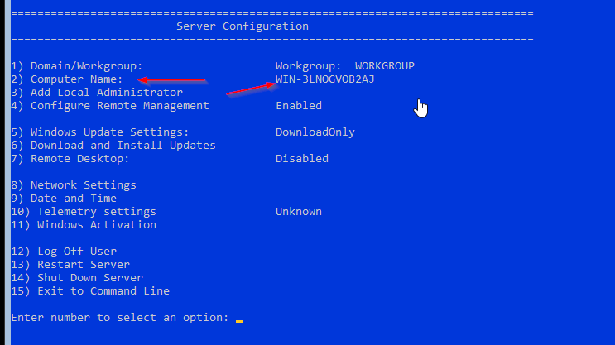

Figure - Change the computer name

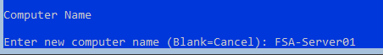

Figure - Type the required text to change the computer name

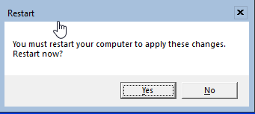

Figure - Restart the computer to apply these changes

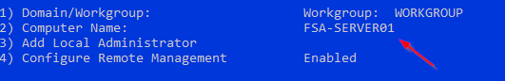

Figure - The showcase of the computer name

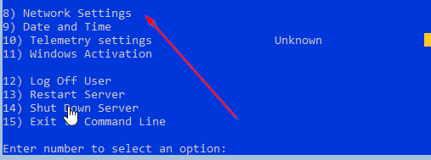

Figure - Go to Network Settings

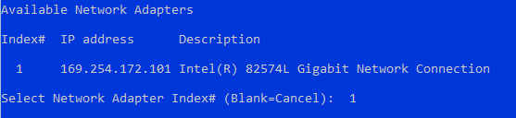

Figure - Use the number one to change the network IP Address

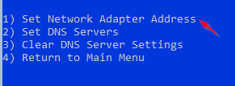

Figure - Set the network Adapter Address

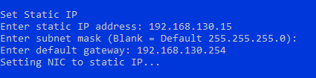

Figure - Set the required manually IP Address

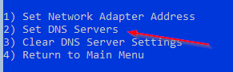

Figure - Set DNS Servers

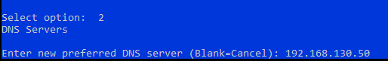

Figure - Set the required manually DNS text on it

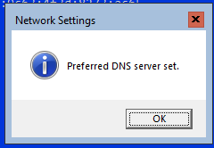

Figure - Done successfully set it

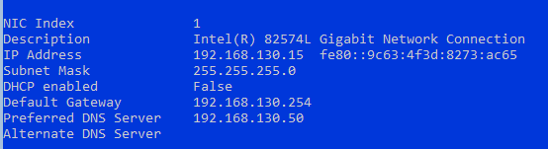

Figure - The showcase of the network setting

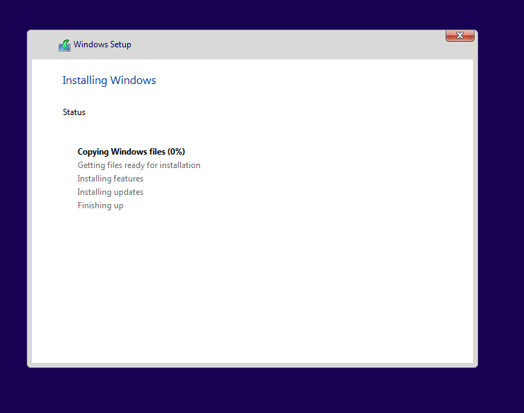

Figure - In VM Window 10, installing

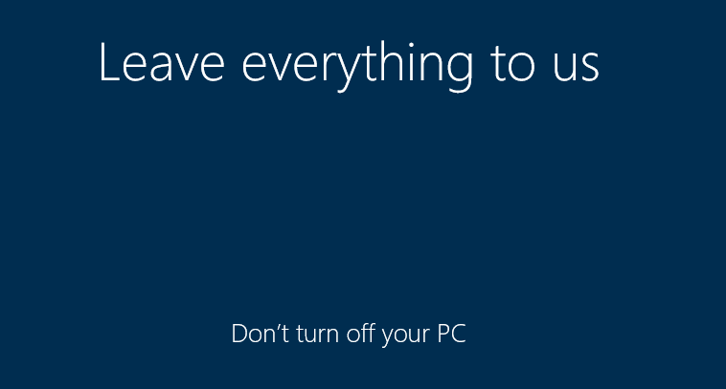

Figure - Boot the window 10 up

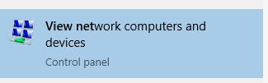

Figure - On WS 10 search, type the required text to check on the network lists

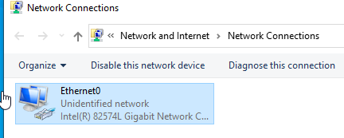

Figure - Click Ethernet0

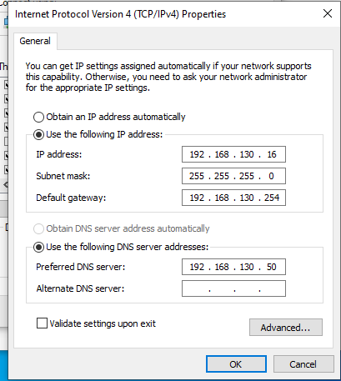

Figure - Put the required manually IPv4 on it and click "OK"

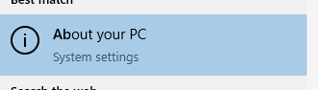

Figure - In Search, type "About your PC" to click

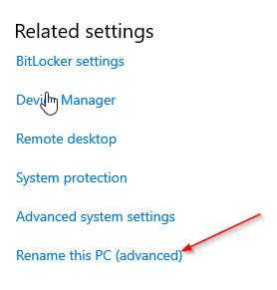

Figure - Click "Rename this PC"

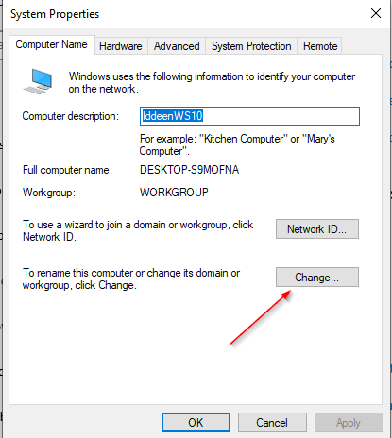

Figure - Click "Change"

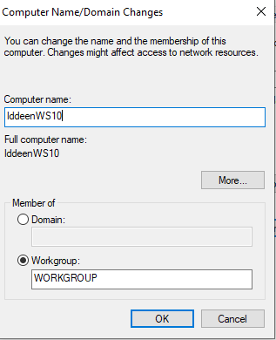

Figure - Change the computer name

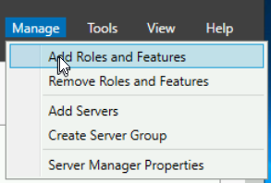

Figure - Add roles and Features

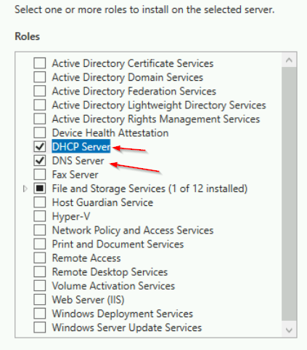

Figure - Select DHCP and DNS Server

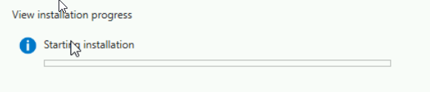

Figure - Starting Installation

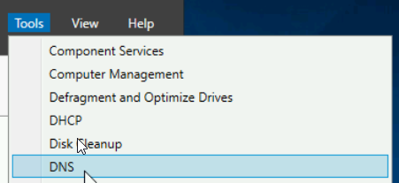

Figure - Click "DNS"

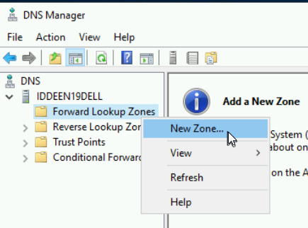

Figure - Click "New zone"

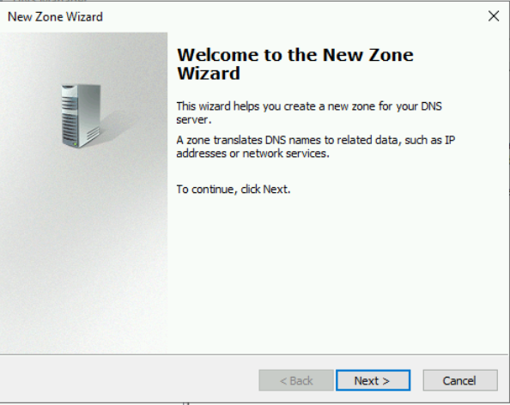

Figure - Proceed to the New Zone

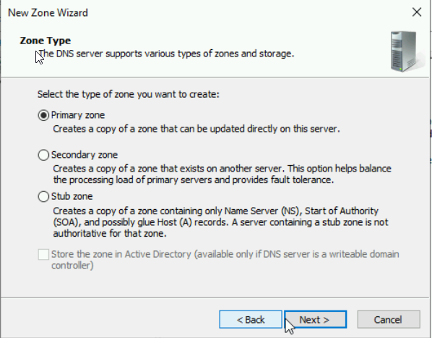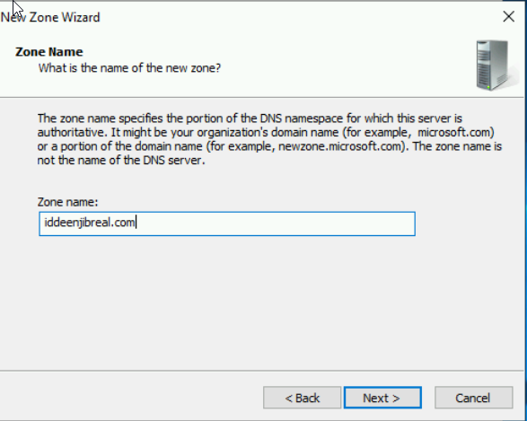

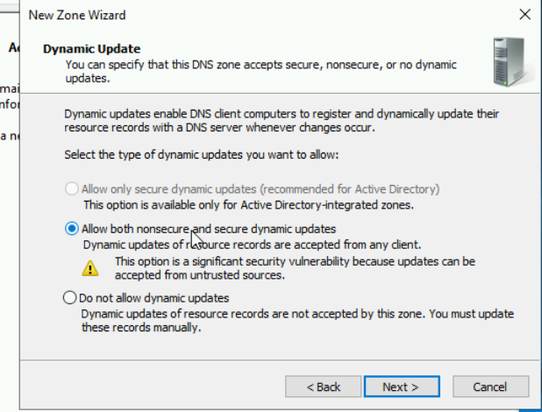

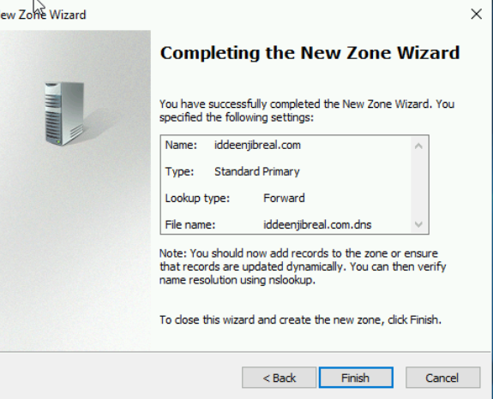

Figure - Successfully completed the new zone Wizard

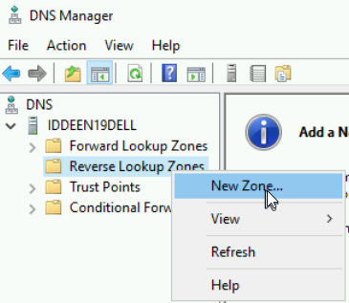

Figure - Proceed to the New Zone for Reverse

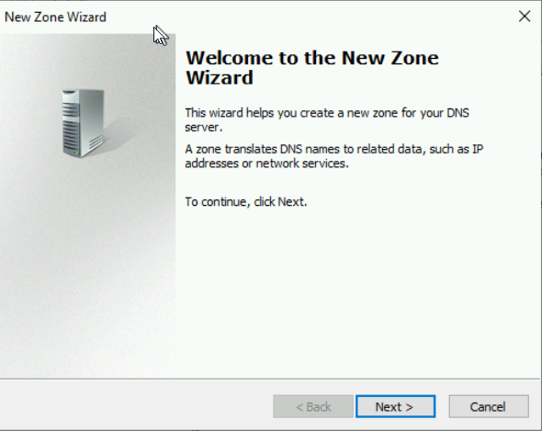

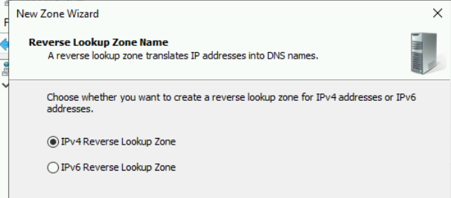

Figure - Make sure to select IPv4 Reverse Lookup Zone

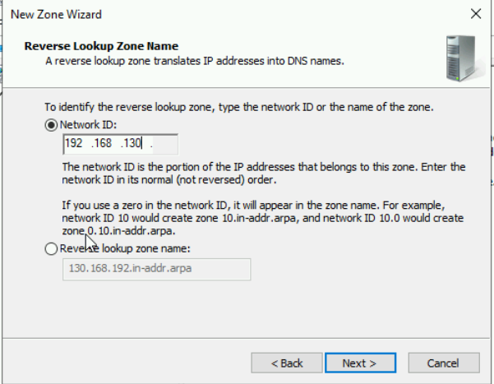

Figure - Put the required IPv4 manually on the Network ID

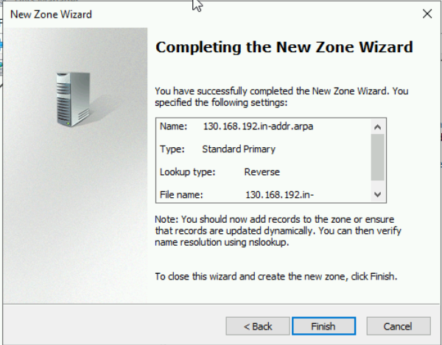

Figure - Completed the New Zone Wizard

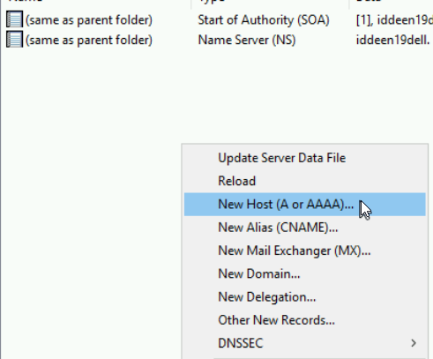

Figure - Click New Host for A to assign the devices

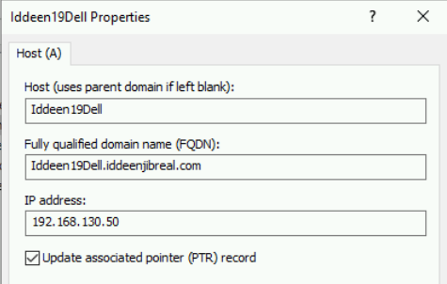

Figure - Assign the devices by using their static IPv4 address

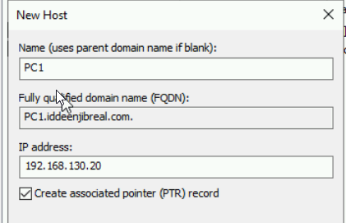

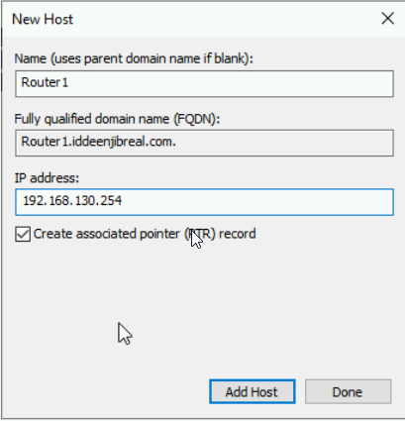

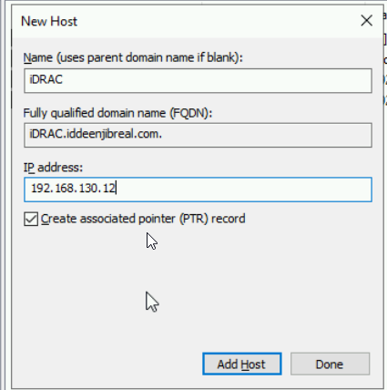

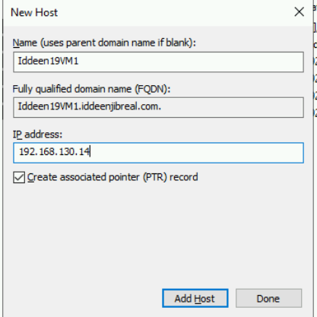

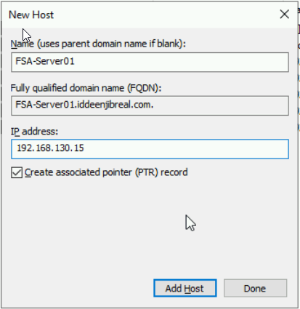

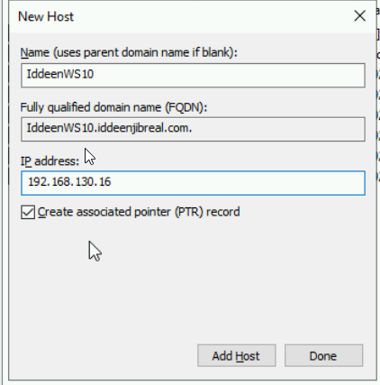

Figure - Done assigning all of the devices

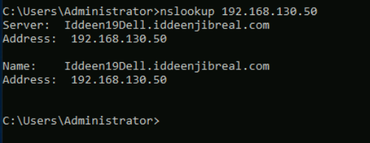

Figure - Use the nslookup command on the DNS Server

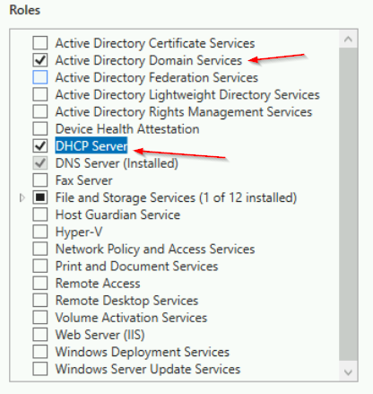

Figure - On the Dell Server, select DHCP and AD Server

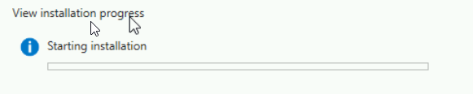

Figure - Starting Installation

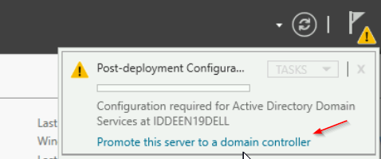

Figure - Promote the server to a domain controller

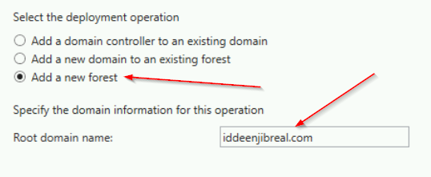

Figure - Add a new forest and type the root domain name

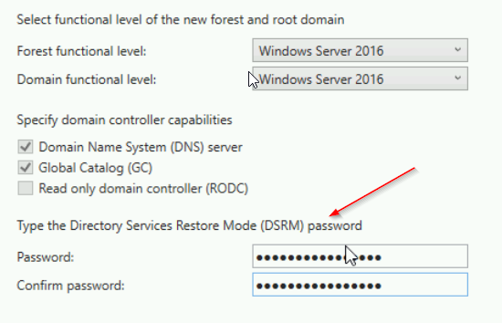

Figure - Type the DSRM Password

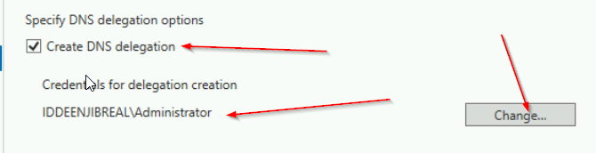

Figure - Create DNS Delegation

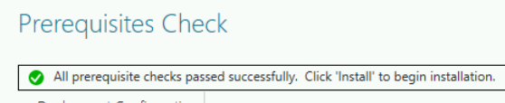

Figure - Make sure to check the prerequisites passed

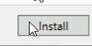

Figure – Install

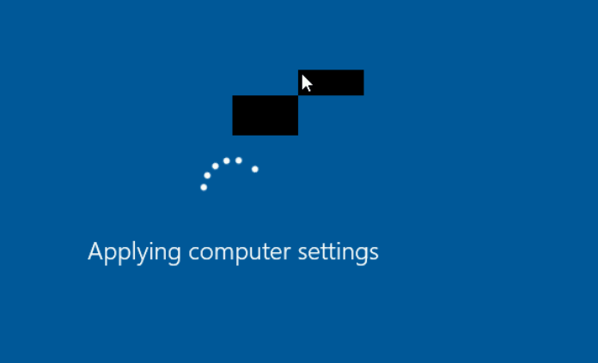

Figure - The AD Service is starting in effect

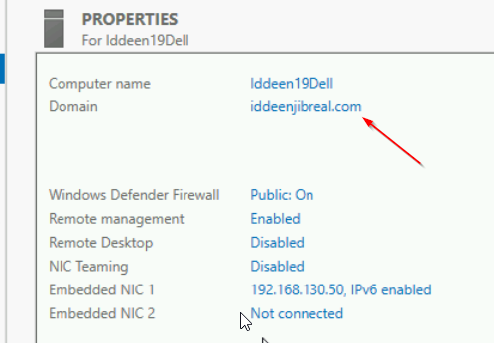

Figure - Make sure to check if you are in the right domain group

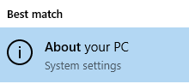

Figure - On VM one, click "About your PC"

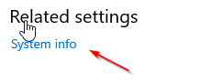

Figure - Click "SYSTEM INFO"

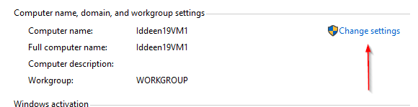

Figure – Click Change settings on that

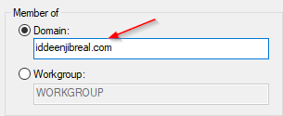

Figure - Type the required text with .com on the member of the Domain

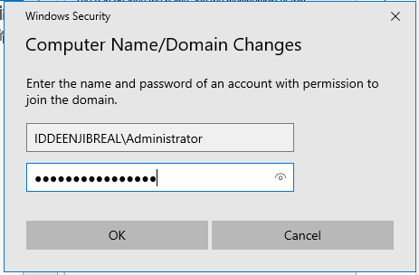

Figure - Log in to the domain account with Administrator

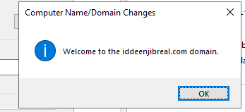

Figure - Successfully joined the domain

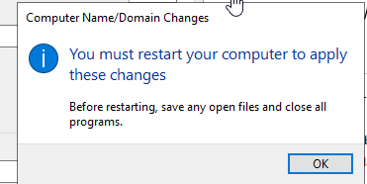

Figure - Restart the computer to apply these changes

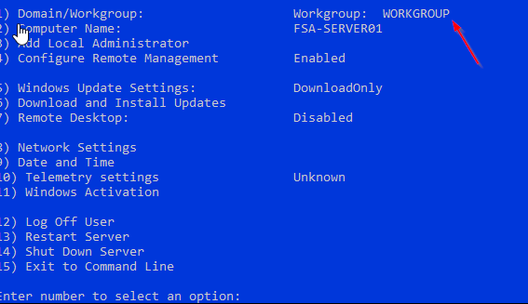

Figure - Type the one number to press the domain/workgroup

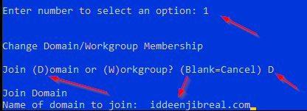

Figure - Press "D" to join the domain and type the required text

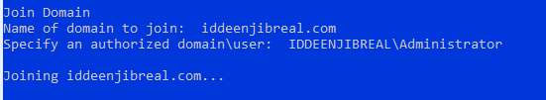

Figure - Log in to the domain group with administrator status

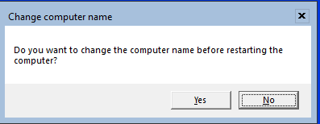

Figure - Restart the computer

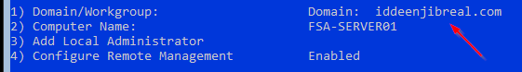

Figure - The showcase of the domain group

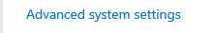

Figure - On VM Windows 10, click Advanced System Settings



Figure - Do the same thing as what I did on VM 1

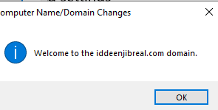

Figure - Successfully joined the domain



Figure - Log out from the WS 10 account

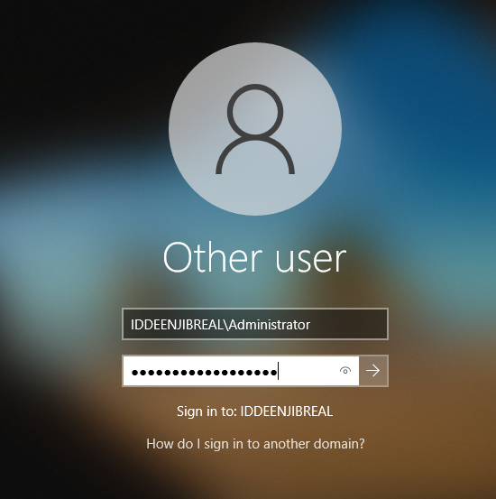

Figure - Log in with Administrator status

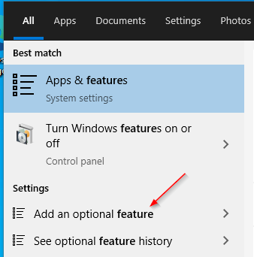

Figure - On WS 10 search, click "Add an optional feature"



Figure - Add a feature

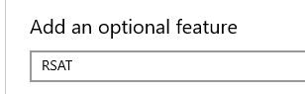

Figure - Type "RSAT" to add an optional feature

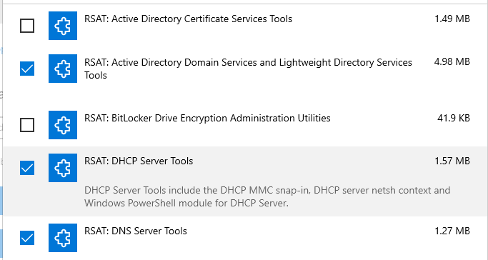

Figure - Select all of the required RSAT services

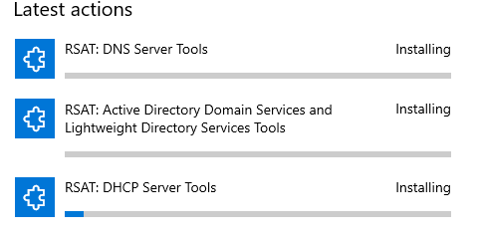

Figure – Installing

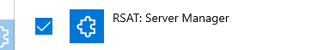

Figure - Select another RSAT service

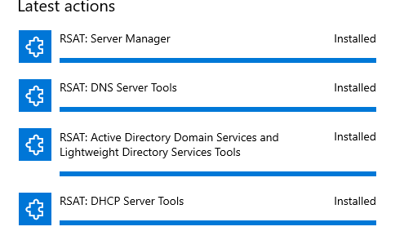

Figure - Installation successfully

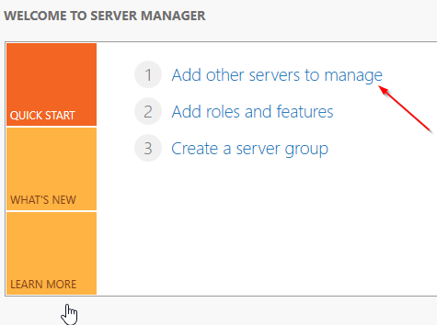

Figure - Click "Add other servers to manage"

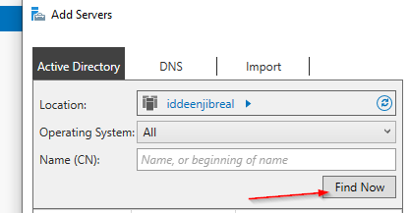

Figure - Click "Find now"

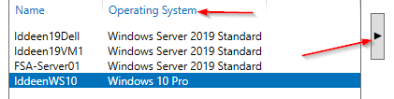

Figure - Invite those OS to join the server

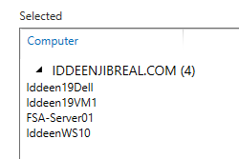

Figure - Invite successfully

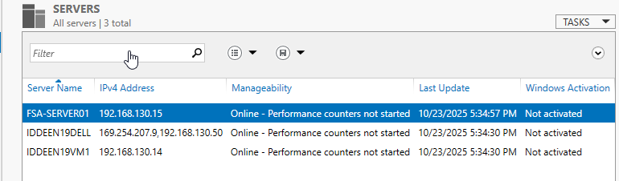

Figure - All of the servers are online successfully

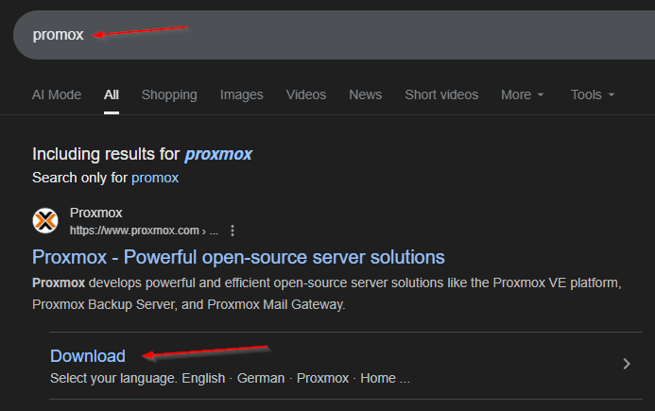

Figure - Type "proxmox" on the google

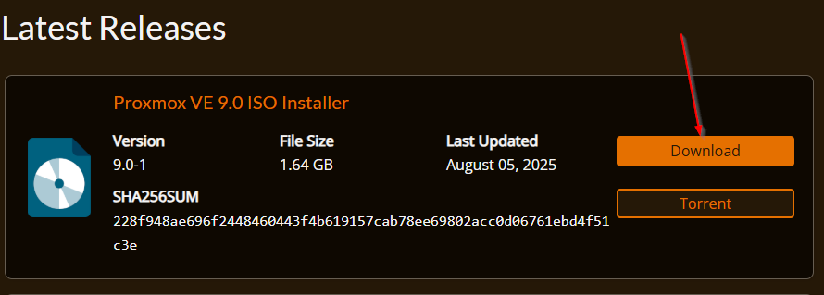

Figure - Download it

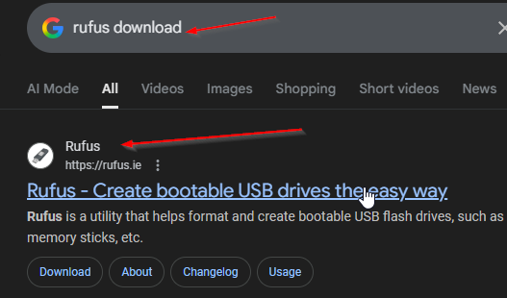

Figure - Type "Rufus" on the google

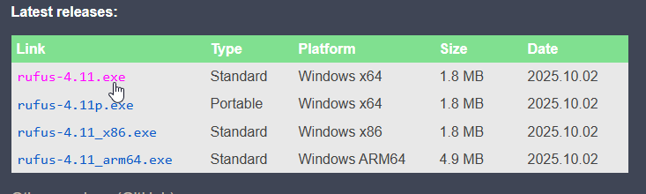

Figure - Download it

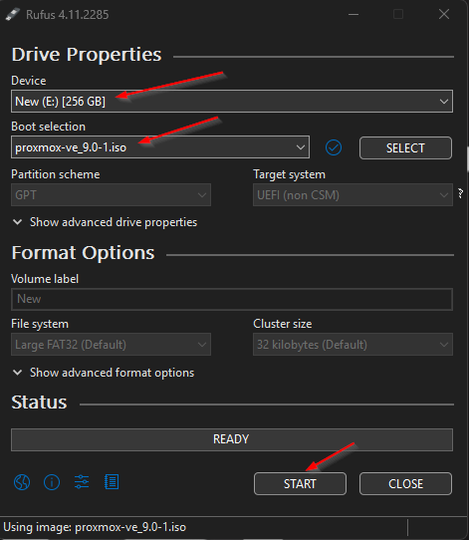

Figure - Use USB to boot Proxmox and click "Start"

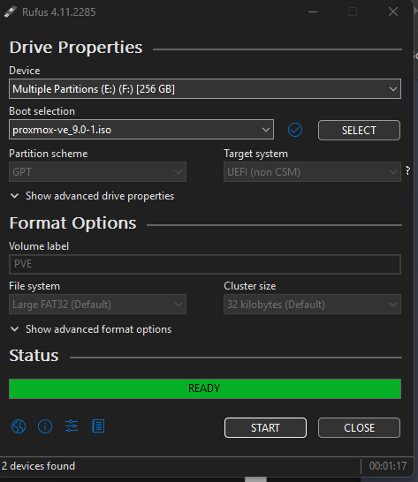

Figure - Ready to boot

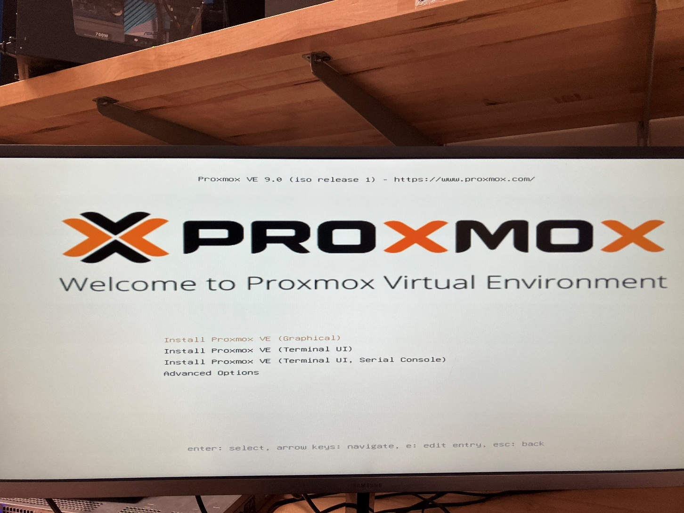

Figure - Proxmox boot completed!

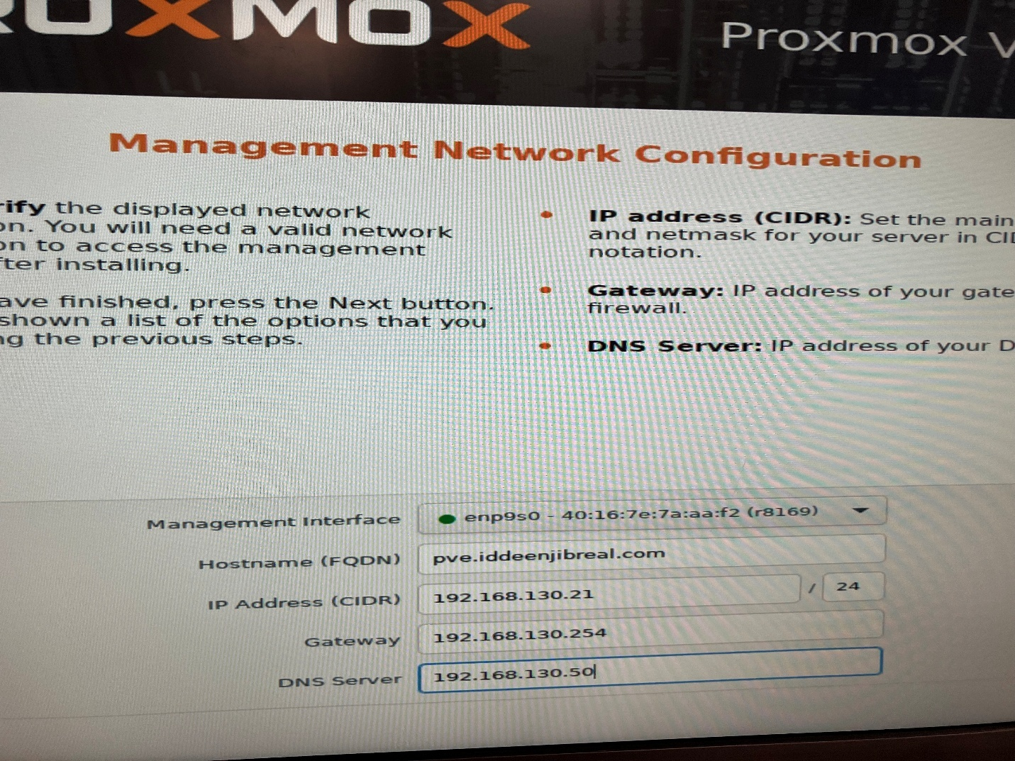

Figure - Set the required IPv4 address and DNS server manually on it

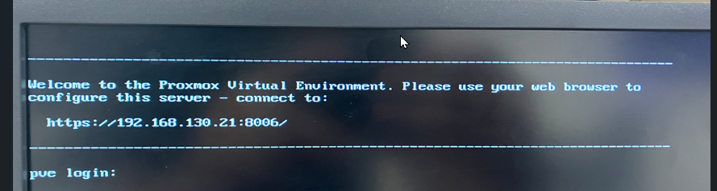

Figure - Use this server url to configure

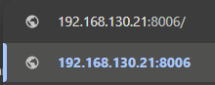

Figure - Use this server url to go

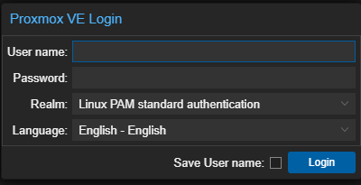

Figure - Log in the Proxmox VE

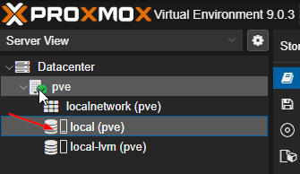

Figure - Click "PVE" then local pve

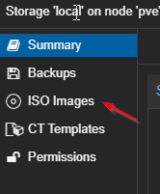

Figure - Click "ISO Images"

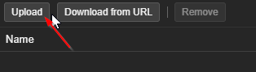

Figure - Click "Upload"

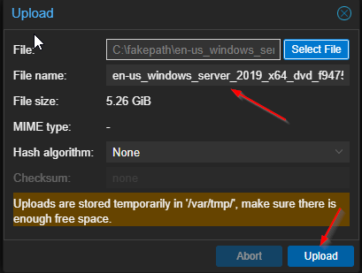

Figure - Make sure to use WS Server 2019 to upload



Figure - Upload another WS 2019 server again

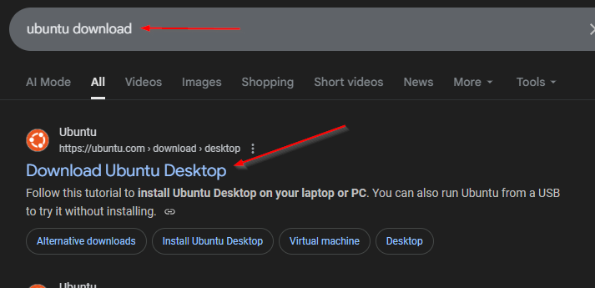

Figure - Type "Ubuntu" on Google

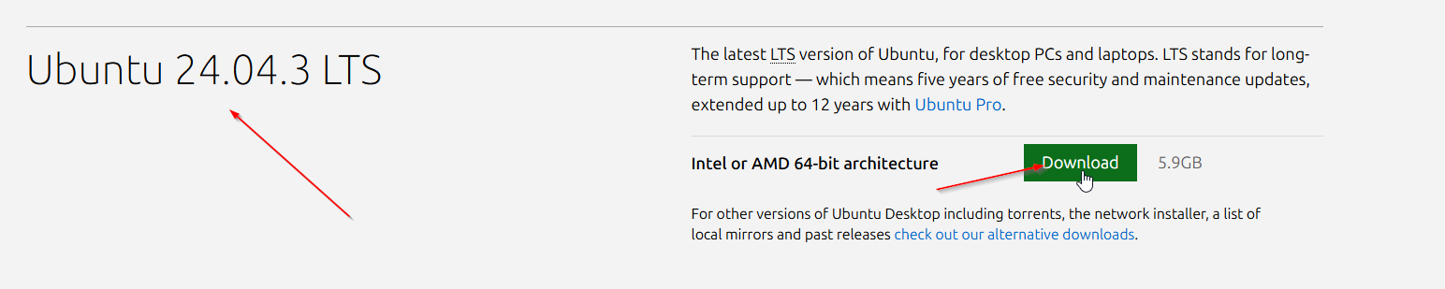

Figure - download the linux

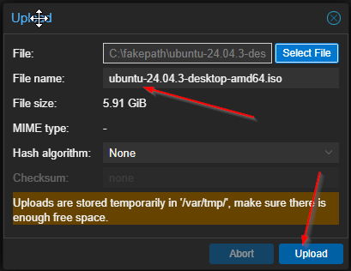

Figure - Upload the Linux ISO file

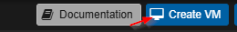

Figure - Create VMS

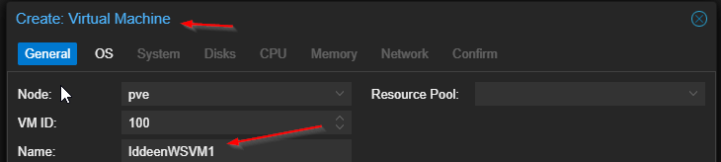

Figure - Create a VM for Windows Server 2019

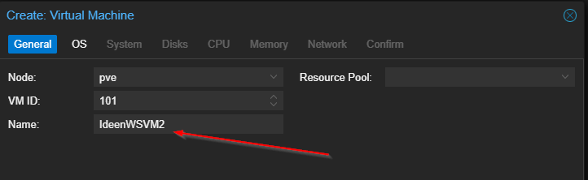

Figure - Create another VM for Windows Server 2019

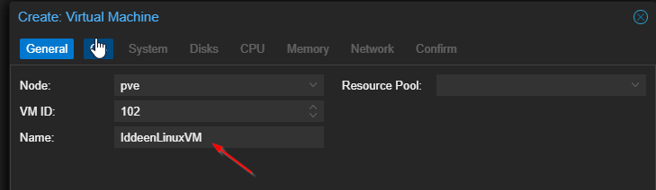

Figure - Create another VM for the Ubuntu client

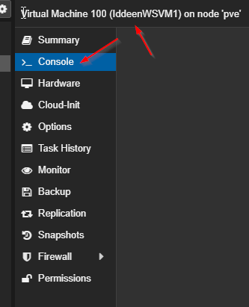

Figure - Click "Console" for the VM WS Server 2019

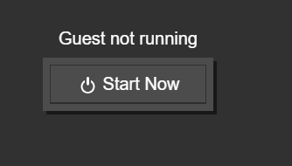

Figure - Start now

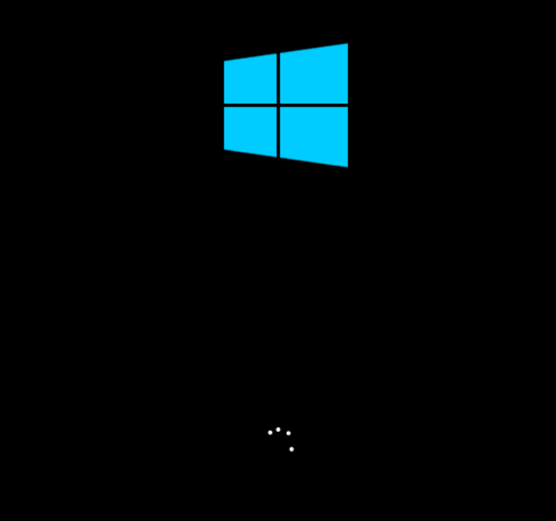

Figure - Boot the Windows Server 2019 up

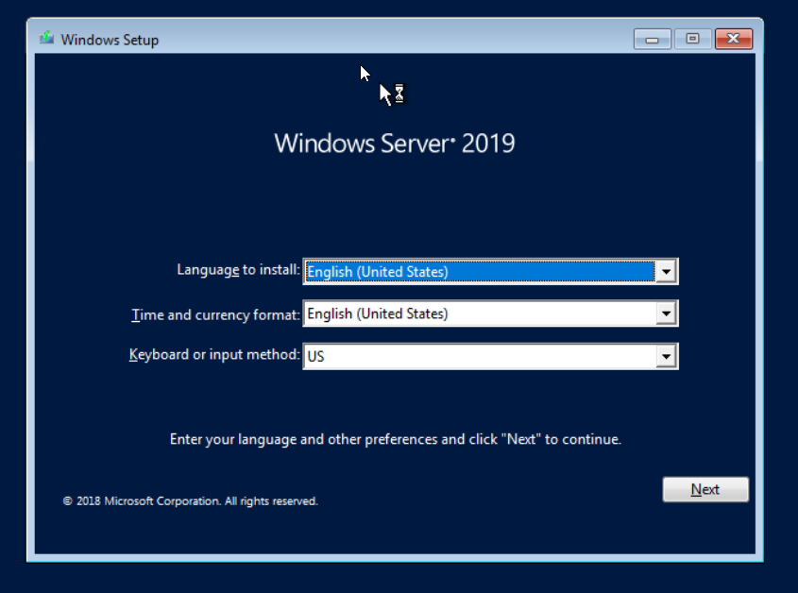

Figure - Proceed with the WS Server 2019 for VM1 and VM2

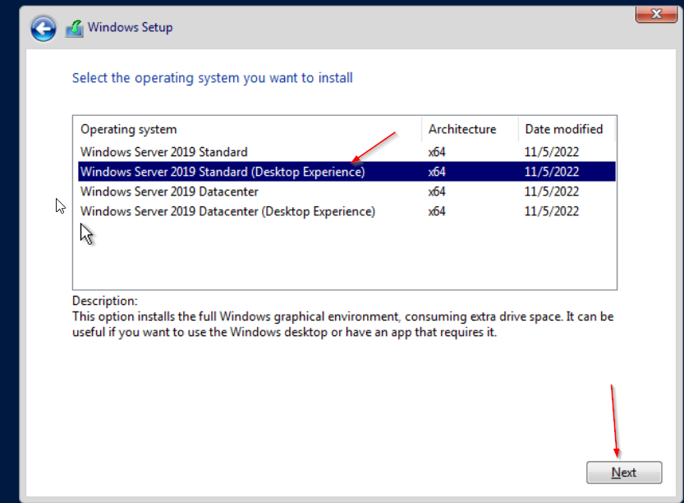

Figure - Click the version with the GUI

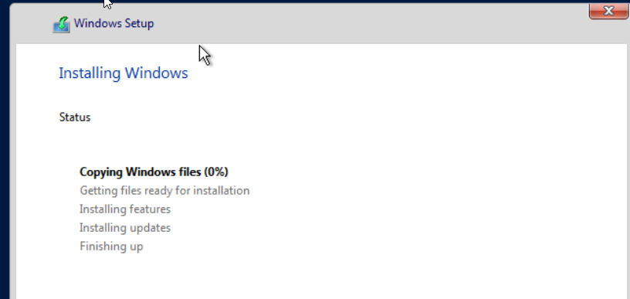

Figure - Installing Windows

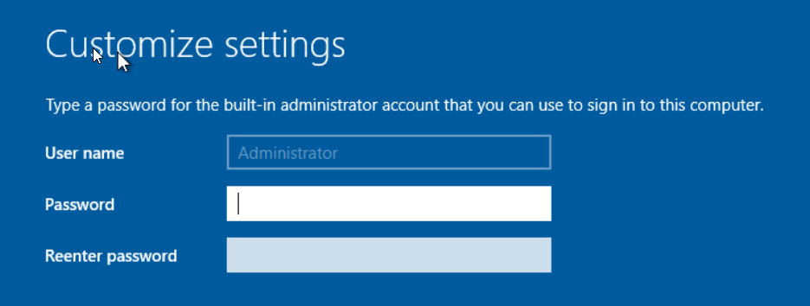

Figure - Create an administrator password

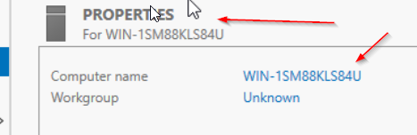

Figure - Change the computer name for VM1

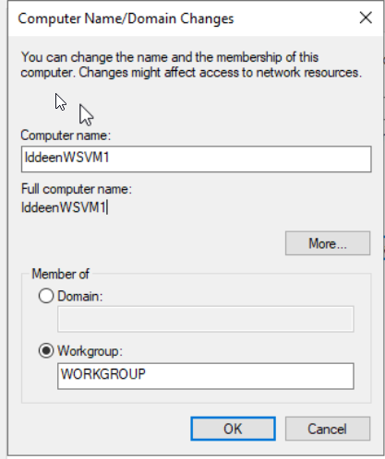

Figure - Change the computer name to apply these changes

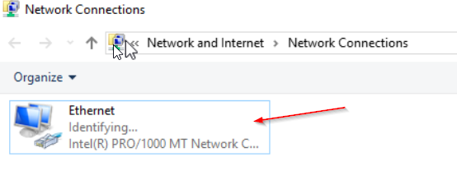

Figure - Go to Network Connections and click "Ethernet"

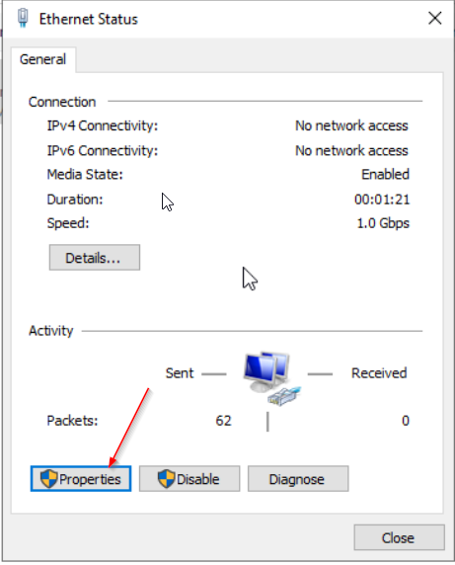

Figure - Click "Properties"

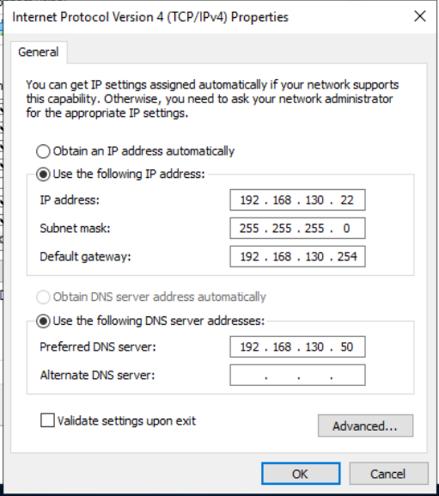

Figure - Set the required static IPv4 and DNS on it

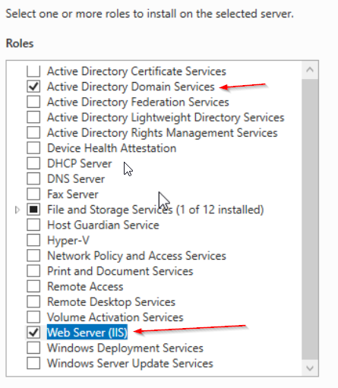

Figure - Select IIS and AD Service to install

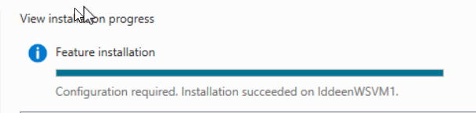

Figure - Installation completed

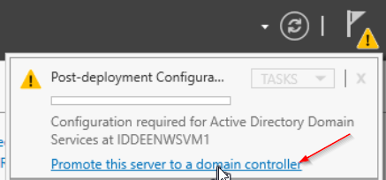

Figure - Promote the server to a domain controller

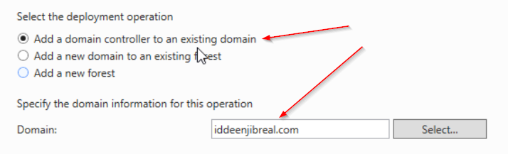

Figure - Add a domain controller to an existing domain and type the name of domain

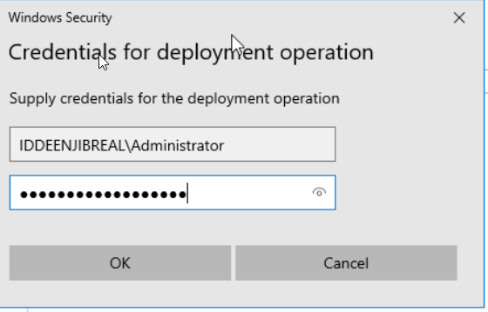

Figure - Log in to the existing domain with administrator status

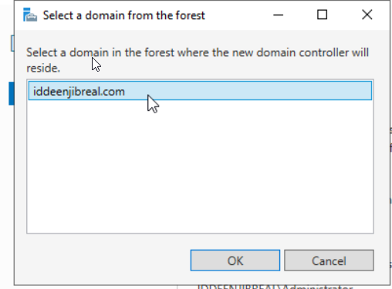

Figure - Select a domain from the forest

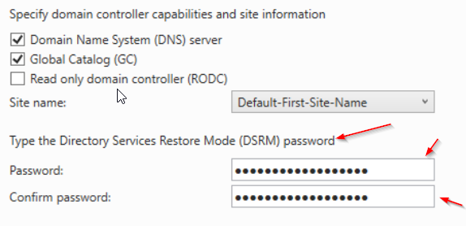

Figure - Set the DSRM Password

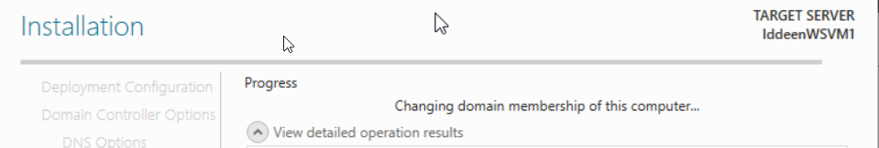

Figure - AD installation in the effect

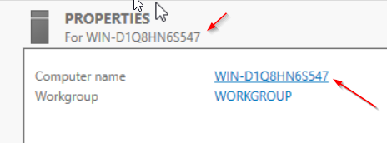

Figure - Click the computer name to change

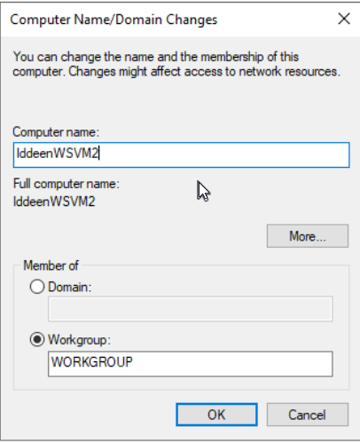

Figure - Change the computer name

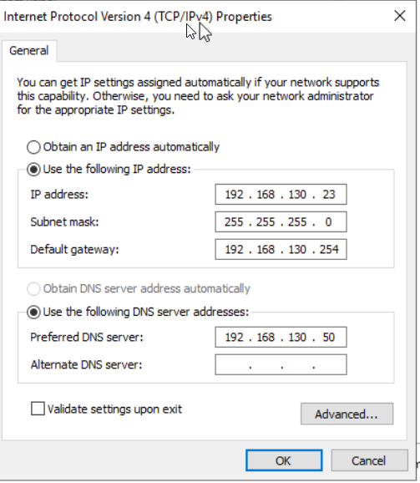

Figure - Set the required static manually with DNS on it

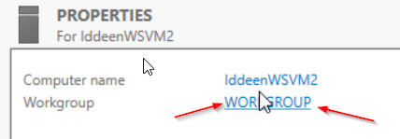

Figure - Click "WORKGROUP"

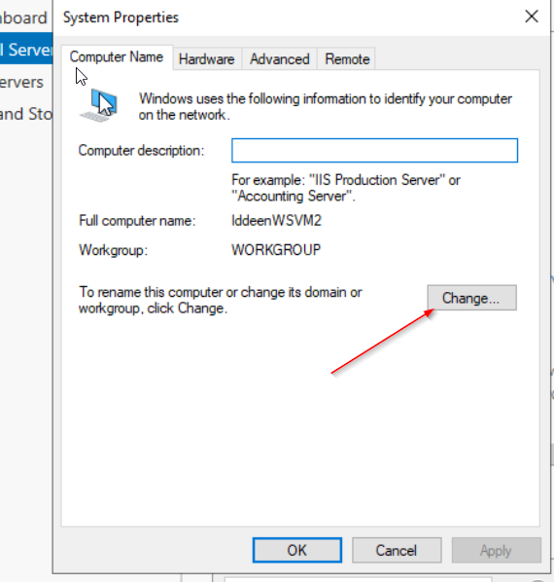

Figure - Click Change

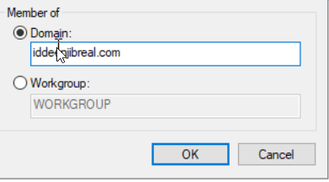

Figure - Type the name of the domain to join

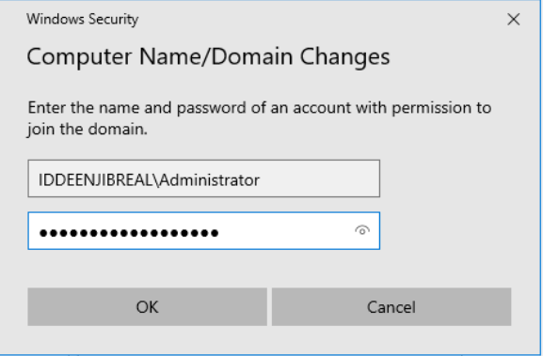

Figure - Log in to the domain with Administrator status

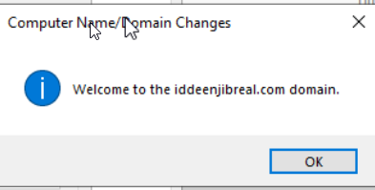

Figure - Successfully joined the domain

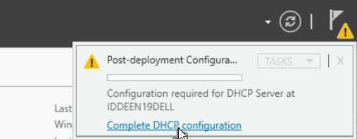

Figure - On the Dell server, complete the DHCP configuration

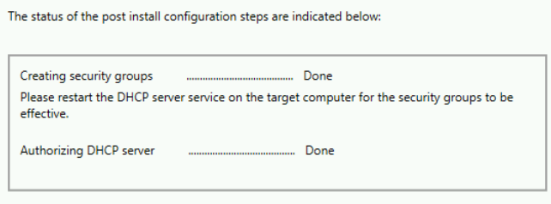

Figure - Authorizing the DHCP server

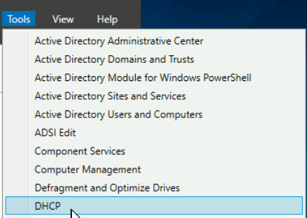

Figure - From the tools, then click DHCP

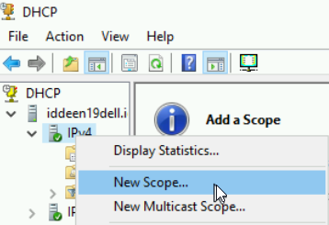

Figure - Click New Scope

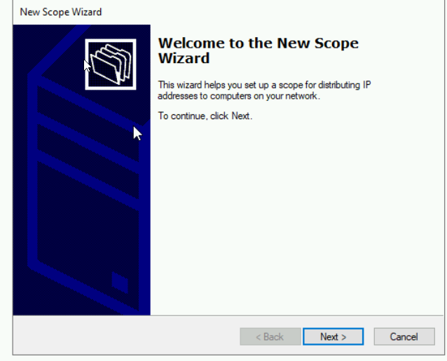

Figure - Proceed with the new Scope Wizard for DHCP

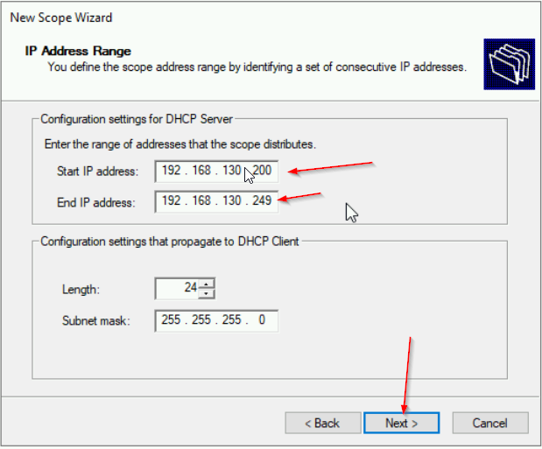

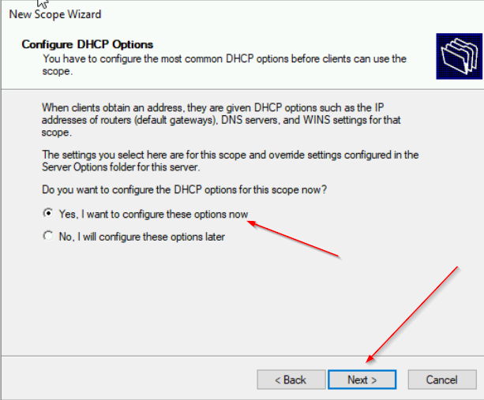

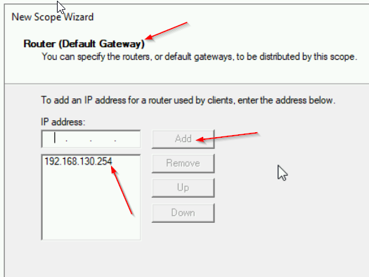

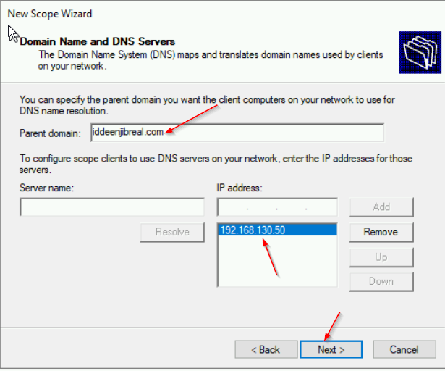

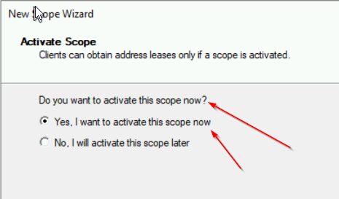

Figure - DHCP Configuration completed. now activate the scope

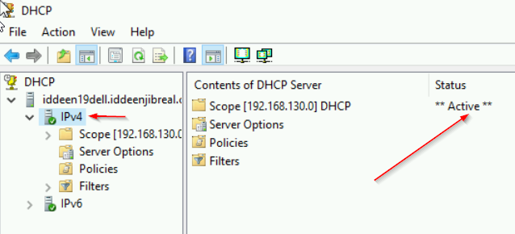

Figure - Make sure to check that the Scope is active



Figure - Boot the Ubuntu

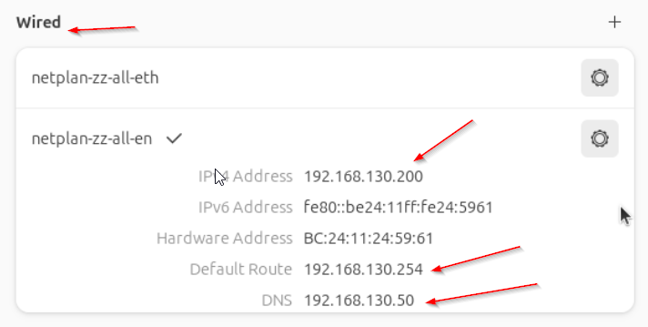

Figure - Check that Ubuntu gets a DHCP IP address

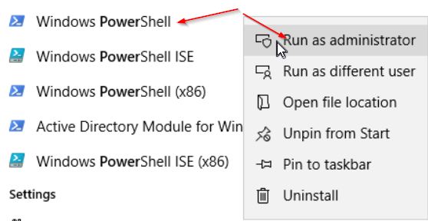

Figure - On Ptoxmox VM 1 WS server 2019, run PowerShell as Administrator

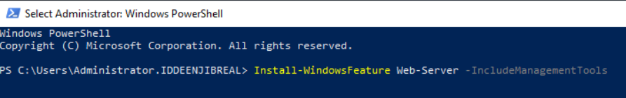

Figure - Use the command to install the Web Server

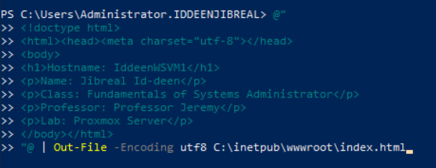

Figure - Use the HTML coding language to create a website

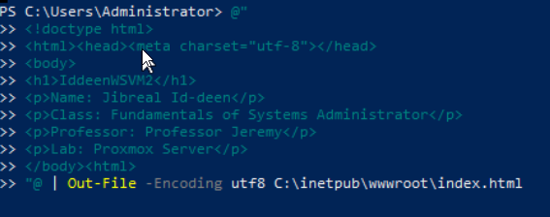

Figure - Do the same thing for another VM with WS server 2019



Figure - On VM Windows 10, use the Edge website to look

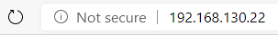

Figure - Type the IP Address to look

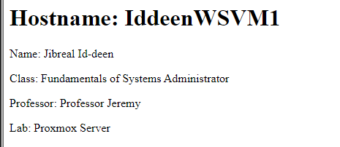

Figure - The showcase of the website created by Proxmox VM

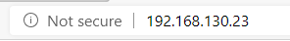

Figure - Do the same thing for another VM on Proxmox

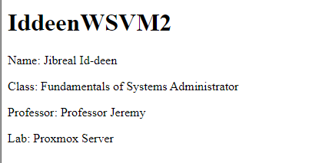

Figure - The showcase of the website created by second VM on Proxmox



Figure - On Ptoxmox VM Linux, go to Firefox to look

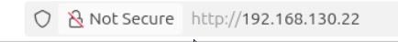

Figure - Type the IP Address from the VM to look

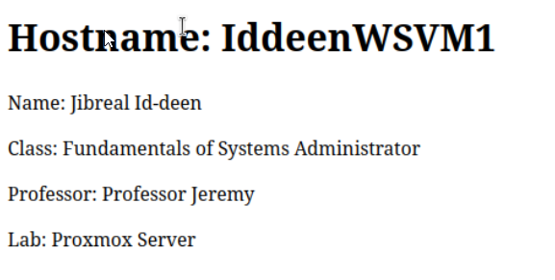

Figure - the showcase of the website created by VM on proxmox

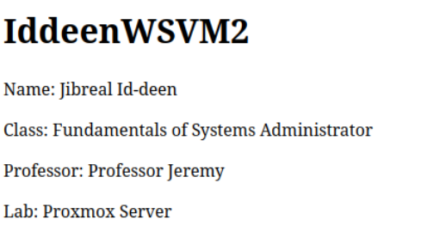

Figure - Do the same thing from the earlier with another IP Address from VMS

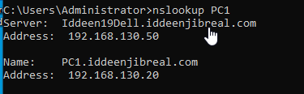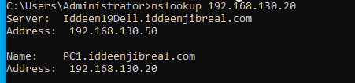

Figure - Use nookup command to look at the IP address and DNS name for PC1

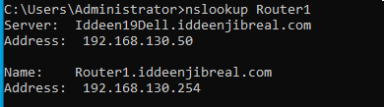

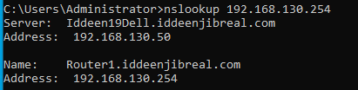

Figure - nslookup for Router

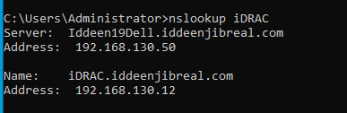

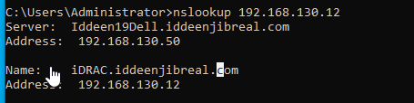

Figure - nslookup on iDRAC

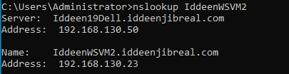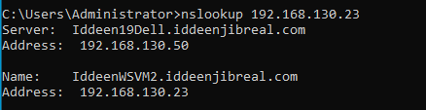

Figure - nslookup on VM

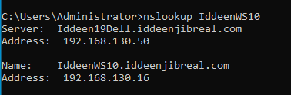

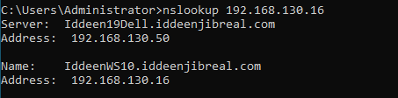

Figure - nslookup on Windows 10

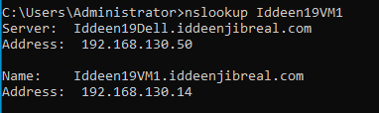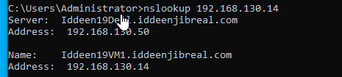

Figure - nslookup on another VMs

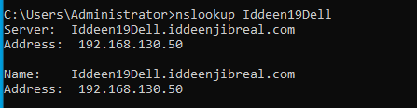

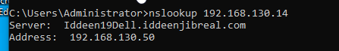

Figure - nslookup on Dell Server

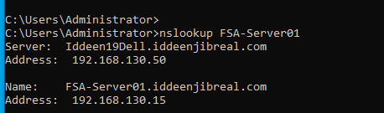

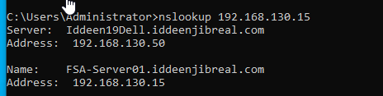

Figure - nslookup on Windows Server 2019 Core

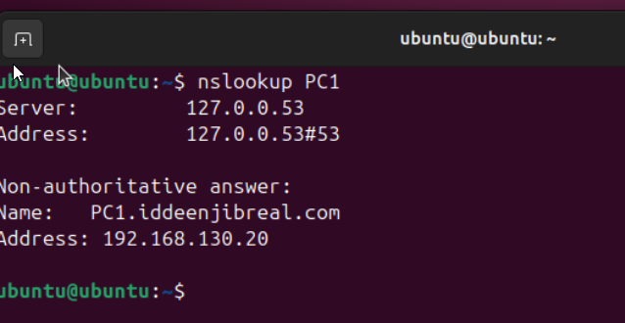

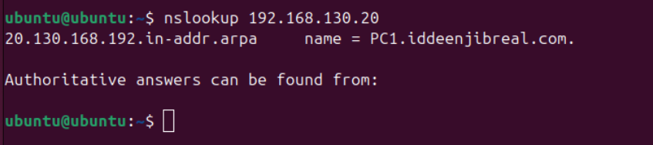

Figure - in ubuntu, use nslookup on PC1

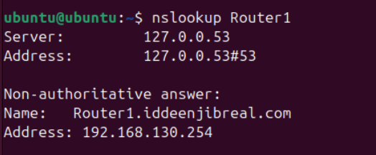

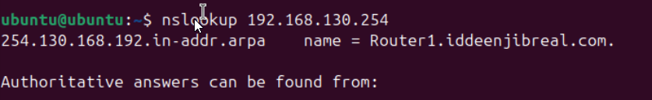

Figure - nslookup on router

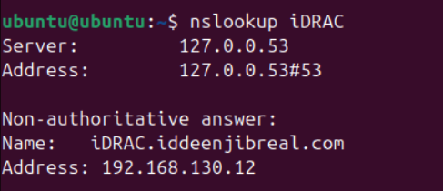

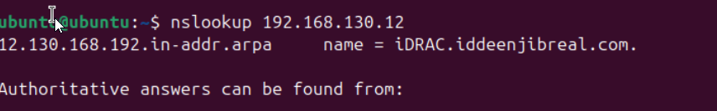

Figure - nslookup on iDRAC

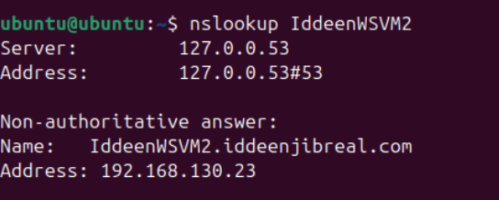

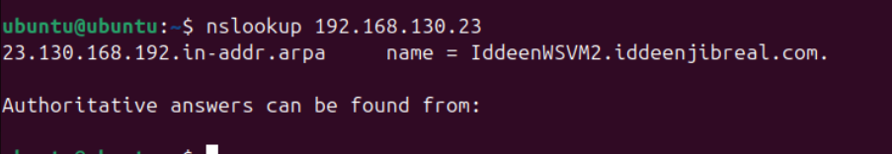

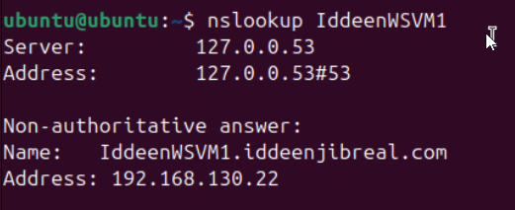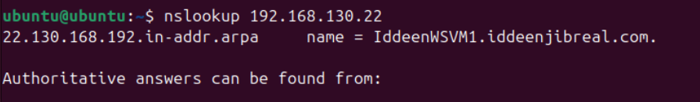

Figure - nslookup on VMs

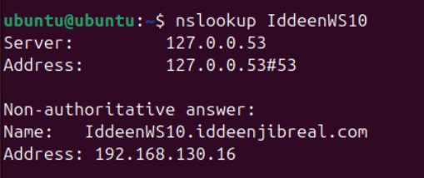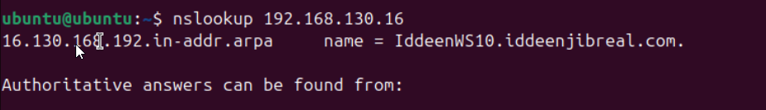

Figure - nslookup on Windows 10

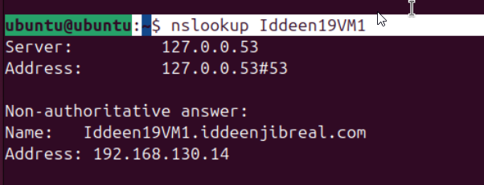

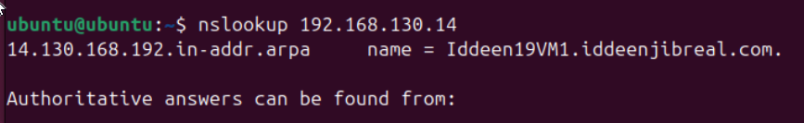

Figure - nslookup on VM

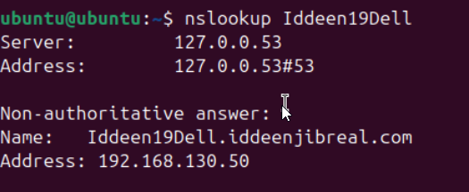

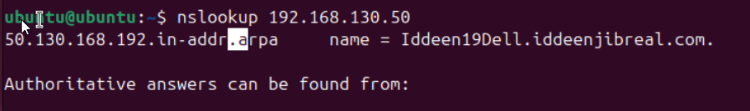

Figure - nslookup on Dell Server

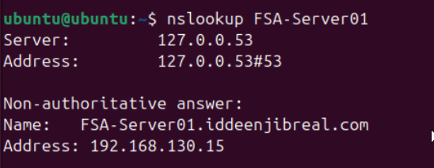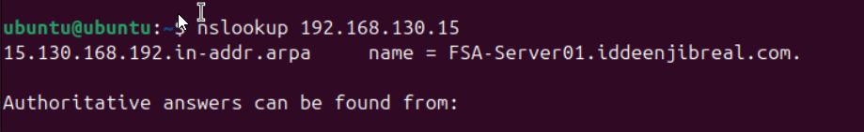

Figure - nslookup on Windows Server 2019 Core

### Questions and Answers

* N/A

### Observations

Wow. This lab was really taking a while to understand the process; it just takes a lot of time to do this much stuff to do. And I lost my original USB; I had to do it again from the start. But it came up faster than I thought.